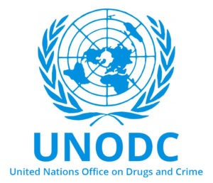
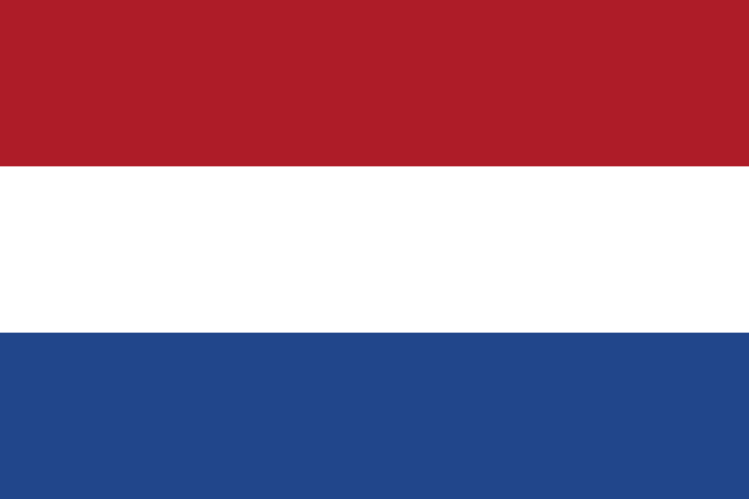

Country:Netherlands
Committee:UNODC(United Nations Office on Drugs and Crime)
Agenda item: Money Laundering and Countering the Financing of Terrorism

Money laundering is a criminal scheme that consists of the illegal process of concealing funds, misleading trace of transactions by making the money obtained appear to have a legitimate source, which is undertaken in order to generate substantial profit.Money laundering creates unpredictable changes in money demand, as well as causing large fluctuations in international capital flows and exchange rates. Money laundering damages financial sector institutions that are critical for economic growth, promoting crime and corruption that slow economic growth, reducing efficiency in the real sector of the economy. Money laundering is a problem not only in the world's major financial markets and sea centers also in emerging markets.Money Laundering and Terrorist Financing is Related to Counterfeiting of Currency.The menace of counterfeit currency is a global phenomenon.

Methods of financing terrorism are globally developing in Countering the Financing of Terrorism. To generate funds for activities is a must for terrorist activities,which procures a need for legal and illegal resort. Crime has become increasingly international in scope, and the financial aspects of crime have become more complex due to rapid advances in technology and the globalization of the financial services industry.Through money laundering,acts of terrorism are supported by criminals.

Money Laundering and Countering the Financing of Terrorism contains various regulations and laws to prevent money laundering, terrorist financing, corruption, and fraud. The Netherlands has comprehensive laws to prevent money laundering and terrorist financing. Financial investigations have been pursued through aggressive and effective approaches. The country has experienced dealing with a variety of terrorist organizations; at present, the main threat seems to come from international Islamic extremists, but the risk is currently deemed to be limited. There is terrorism and terrorist financing risk, but it appears limited based on available information. The country has experienced dealing with a variety of terrorist organizations; at present, the main threat seems to come from international Islamic extremists, but the risk is currently deemed to be limited.

Ece Vardarös

https://www.hsdl.org/?view&did=3549

https://www.munpoint.com/mun/documentcenter/studyguide-4512-1638744781-9362.pdf

https://en.m.wikipedia.org/wiki/Money_laundering

https://www.imf.org/external/pubs/ft/scr/2011/cr1192.pdf

