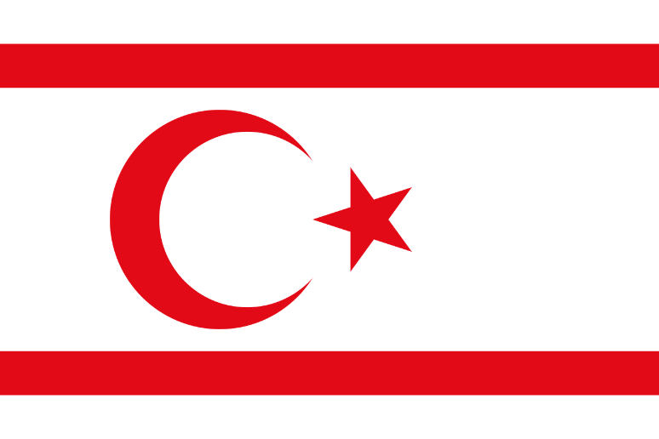
POSITION PAPER
Delegate: Irmak Açıkgöz
Country: Turkish Republic of Northern Cyprus
Committee: Historical UNSC
Topic: Representative of Turkish Cypriots(TRNC)

The Turkish Republic of Northern Cyprus is a country supported by Turkey economically, politically and militarily. The important settlements of the TRNC(Turkish Republic of Northern Cyprus) of are the capital Nicosia, Girne, Famagusta, Güzelyurt and İskele. There are also natural caves in the north of the island. It has around 85 natural caves, including the İncirli Cave with its stalactites and stalagmites, and the Sütünlu Cave in İnönü. The Turkish Republic of Northern Cyprus is governed by a semi-presidential system. While the district with the smallest area and population is Lefke, the largest population is located in Nicosia and the largest area is located in Famagusta. The service sector, which includes the public sector, trade, tourism and education, dominates the economy of Northern Cyprus. The income earned by the education sector in 2011 is $400 million, while industry contributes 22% of GDP and agriculture 9%. The economy of Northern Cyprus is based on the free market and in 2014 the country ranks first in Europe in terms of starting a new business. .
The Historical Security Council is a permanent council established by the UN Charter, with the sole purpose of maintaining international peace and security. The UNSC is the only council that can force a nation to do something, as long as it passes in a Resolution. The UNSC may also establish subcommittees to aid its efforts, and can call for investigations of fact-finding missions to obtain more information on a dispute.

If we look at the developments since the emergence of the Cyprus problem, it is possible to see the policies that both Turks, Greek Cypriots and Greek Cypriots followed and should follow in history. Greece and Greek Cypriots have based their basic and unchanging policies on Enosis, which means the union of the island with Greece, from the moment the island of Cyprus came out of Turkish domination. As it is known, Cyprus passed under Turkish rule in 1571. It remained under Turkish rule for 307 years until 1878. With the defeat of the Ottoman Empire in the Ottoman-Russian-Romanian War of 1877-1878, which we call the 93 War, the Russians came to Erzurum on the one hand and Istanbul Yeşilköy on the other hand and had the Ottoman Empire sign it. Aya Stefanos Agreement with very difficult conditions. . Seeing that the Russians were coming to dominate the straits and Istanbul, England demanded that the island of Cyprus be temporarily given to it from the Ottoman Empire. It would use this island as a base and would be able to intervene more effectively and quickly against the Russian threat in the region when necessary. The Ottoman State accepted this request and left the administration of the island to England. England After the World War II, he had to leave the regions connected to him, so he established the independent Republic of Cyprus in 1960 and ended his sovereignty on the island. After 1960, there were Greeks, Turks, Turkey, Greece and England on the island. After the Peace Operation of the Turkish Armed Forces in 1974, a new formation and a new era began on the island. Now Greeks lived in the south and Turks in the north. This situation continues today.

We believe that in this committee, safe decisions will be taken in favor of everyone regarding the Cyprus problem. We are ready to share/use all our resources with everyone and to come together and form strong alliances with countries.

Sources:
https://www.asf.edu.mx
https://www.icj-cij.org/en
https://atamdergi.gov.tr/tam-metin-pdf/381/tur

