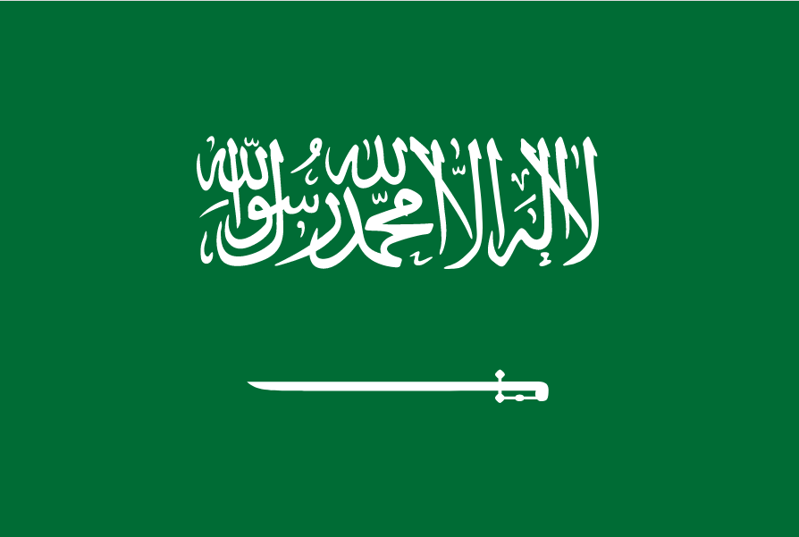 Commitee: The Commission on the Status of Women(CSW)
Topic: Recognition and Visibility of Transgender Women
Country: The Kingdom of Saudi Arabia

About Our Country
The Kingdom of Saudi Arabia is proud to be a part of this commission created to resolve a very important issue. The Kingdom of Saudi Arabia, is a country in Western Asia. It spans the vast majotary of the Arabian Peninsula with a land area of approximately 2,150,000 km² .Saudi Arabia is largest country in the Middle East and the current population of Saudi Arabia is 35,59 million. The capital of Saudi Arabia is Riyadh. Saudi Arabia is a respectable member of the United Stations since the year of 1945.
The Issue And Our Country’s Point of View
Saudi Arabia is a developing country in the face of difficulties. One of the most important issues in Saudi Arabia is the issue of transgender women. In the current age, the topic of transgender women is involving all the countries. For Saudi Arabia, this topic is a particular concern to the country every aspect.
According to the laws of Saudi Arabia and Sharia law, same-sex behavior, including transgender women, who can be referred to as "men posing as women." is a crime.As social media has been shaped by the values of the west, people have been exposed to more stimulating behavior. Therefore, this has become an important issue to address in our country.
Our Sollution Ideas
Saudi Arabia offers rehabilitation to individuals who are confused about this issue. In addition, deterrent penalties such as imprisonment, corporal punishment or the death penalty are also provided for homosexual acts and wearing the clothes of the opposite sex in this regard
Saudi Arabia is proposing transgender women free or low-cost treatments aimed at getting them to return to their biological sex. At the same time, Saudi Arabia proposes to use as humane methods as possible when encouraging people to their biological sex
Sources Used İn The Presentation
https://tr.wikipedia.org/
https://www.worldometers.info/
https://en.wikipedia.org/
https://www.bbc.com/

