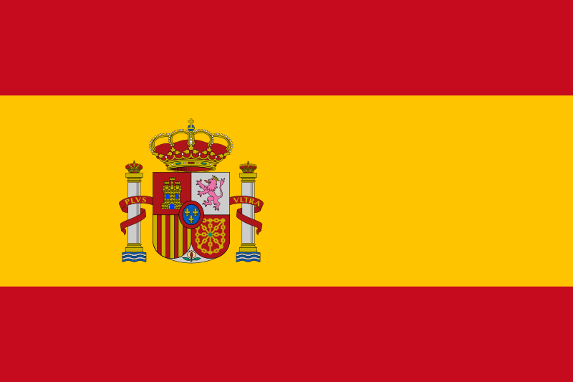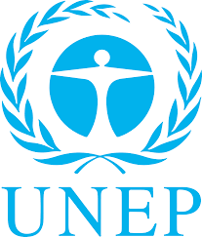

POSITION PAPER
Delegate : Nisa Seçer Country : Kingdom of Spain
Committee : United Nations Environment Programme
Agenda Item: Enhancing the transition to sustainable energy as a response to the energy crisis and climate change

- Basic Information About the Country
Spain or the Kingdom of Spain is a country in southwestern Europe with parts of territory in the Atlantic Ocean and across the Mediterranean Sea. With an area of 505,990 km2 Spain is the largest country in Southern Europe. With a population exceeding 47.4 million, Spain is the sixth-most populous country in Europe, and the fourth-most populous country in the European Union.Citizens of Spain try their best for a more nature friendly world.

- Commitee
The United Nations Environment Programme (UNEP) was established by the UN General Assembly in 1972. UNEP works closely with its 193 Member States and representatives from civil society, businesses, and other major groups and stakeholders to address environmental challenges through the UN Environment Assembly, the world’s highest-level decision-making body on the environment. UNEP works on delivering transformational change for people and nature by drilling down on the root causes of the three planetary crises of climate change, nature and biodiversity loss, and pollution and waste.

- Expectation(s)
We believe that this committee and the conference promise great national and international developments which will help generations to live in a healthy, clean and better world.We don’t want to be late for this worldwide goal and we must start and continue to the reasonable solutions together.

- Solution(s)
We think that raising awareness in this issue is very important.Since our main topic which is climate change is not only Spain’s problem, we must take actions together and implement them to citizens’ lives.

​

