GA:1 DISEC - Weaponization of Data and Cyber Security
Delegate of Russian Federation’s Position Paper

- Information About Our Country
Russian Federation is a transcontinental country spanning Eastern Europe and Northern Asia. It is the largest country in the world by area, covering over 17,125,191 square kilometres (6,612,073 sq mi), and encompassing one-eighth of Earth's inhabitable landmass. Russia extends across eleven time zones and borders sixteen sovereign nations, the most of any country in the world.[d] It is the ninth-most populous country and the most populous country in Europe, with a population of 145.5 million. The country's capital and largest city is Moscow, the largest city entirely within Europe. Saint Petersburg is Russia's cultural centre and second-largest city. Other major urban areas include Novosibirsk, Yekaterinburg, Nizhny Novgorod and Kazan.
- Our Countries Point Of The View
Our country takes many precautions in response to cyber security problems. To give an example of these; informative ceremonies for students in schools, promotions to increase the use of web 3.0, our cyber security team is ready for any possible attacks etc.

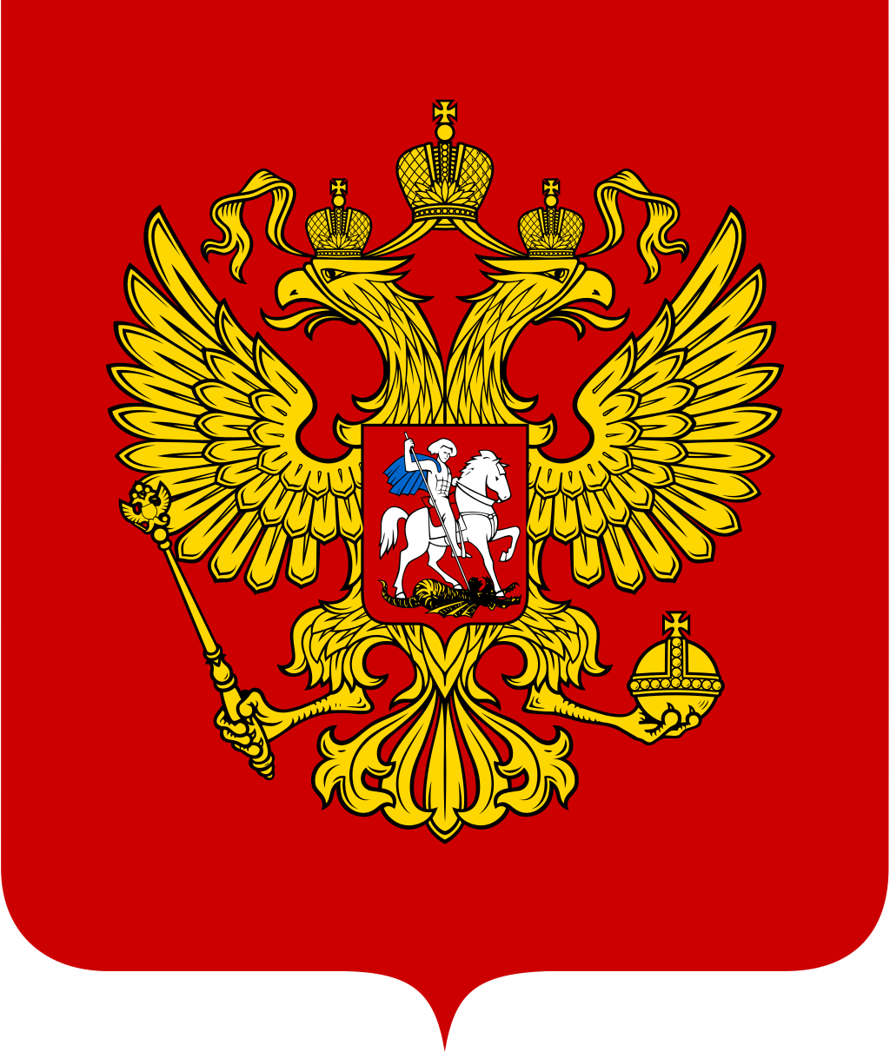
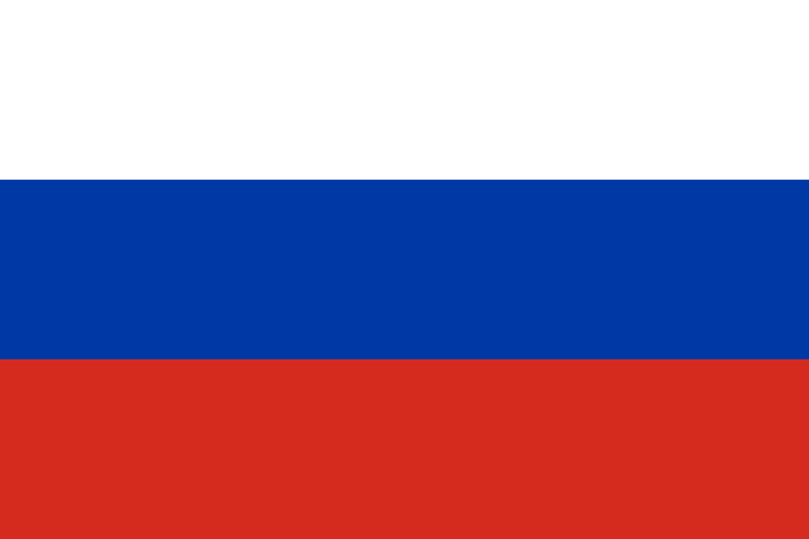
Organizations That Can Influence;
1.Open-ended Working Groups (OEWG)
2.Group of Governmental Experts (GGE)
3.International Police (INTERPOL)
4.Information Sharing and Analysis Center (ISAC)
5.International Multilateral Partnership Against Cyber Threats (IMPACT)

These Organizations can be helpful for solving the current problems. Our opinion is using International Multilateral Partnership Against Cyber Threats (IMPACT) will be efficient for finding some permanent solutions for all world. Our other opinion is creating Cyber Security Teams, with these teams all of the countries which is agreed will be protected by these teams from any kind of cyber attacks. The criminals which is did cyber crimes will judged by Cyber Security Council (CSC). CSC will be working for all world, that means that it will be fair for all criminals. Our another solution idea is to creating borders for all countries which is agreeing with this opinion, the borders will be same as the borders which is countries has it as in the physical way. Passing these
Borders will be a crime and passing them will be a declaration of war.
- References
https://en.wikipedia.org/wiki/Russia https://threatmap.checkpoint.com https://www.checkpoint.com/cyber-hub/cyber-security/what-is-cyber-attack/ https://www.bbc.com/news/world-60525350 https://en.wikipedia.org/wiki/International_Multilateral_Partnership_Against_Cyber_Threats

