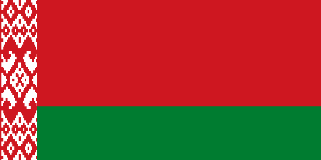

ISRAEL-PALESTİNE CONFLİCT

DELEGATE OF BELARUS

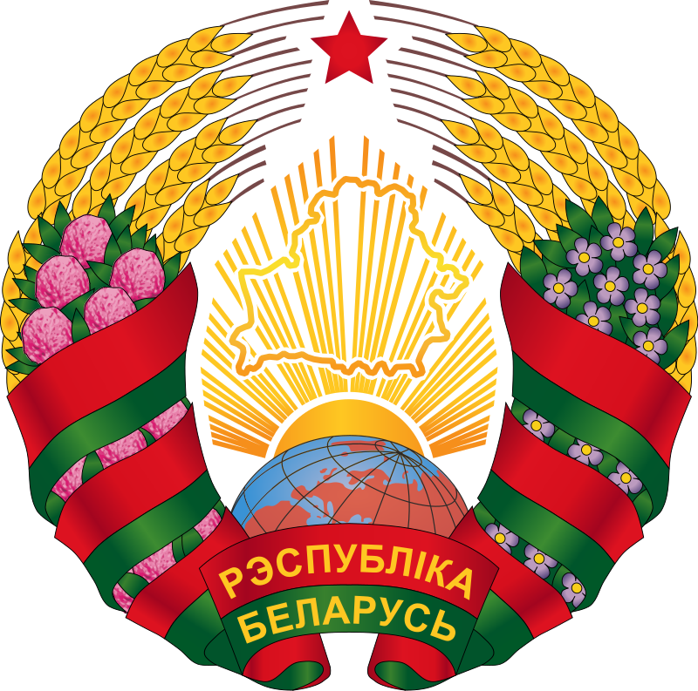
POSİTİON PAPER

- About Our Country:
  - Belarus, is a state located in Eastern Europe. It is a former Soviet Union country that declared its independence with the dissolution of the Soviet Union in 1991. The capital of Belarus, a Slavic state, is Minsk. Neighbors; Poland to the west, Lithuania to the northwest, Latvia to the north, Russia to the east, and Ukraine to the south. Let's talk a little bit about the nationality distribution of our citizens: Ethnic White Russians make up 81.2% of Belarus' total population. The next largest ethnic groups are Russians (11.4%), Poles (3.9%) and Ukrainians (2.4%). The two official languages ​​of Belarus are Russian and Belarusian. Russian is the most common language in the country, spoken by 72% of the population; Belarusian is spoken only by 19.2% of the population. Polish, Ukrainian, and eastern dialects of Yiddish are spoken by minorities.So the population of our country is 9,399 million.

Our Countries Point Of The View:
  - Our country has always been a supporter of peace. Because war cannot solve anything.We do not want this conflict between Israel and Palestine to continue any longer. Both Israel and Palestine are countries with official borders. And they also have their own political opinions, we want these two countries to make an agreement by respecting their thoughts and profits, which we think should be resolved in this way. Because every second that passes is causing a few more people to die. We know that many agreements have been signed and broken before, but we believe that a new agreement can be made in a new environment where the opinions of both parties are listened to. This is what we consider the most reasonable among the solution methods.
  - The lands Israel is currently on are the lands they have officially purchased. Therefore, we think that the Palestinian views on this issue are wrong. And Israel, which became official in Tel-Aviv by David-Ben Gurion on May 14, 1948, was attacked by Palestinian and Arab soldiers in 1948, the year its country became official. This aggressive attitude may not mean that they hold grudges against a Jewish community, but it does mean that they do not respect the official borders of other nations. And that's why Israel has reacted back to protect itself and its citizens. If we were experiencing the same situation in our own country, we would have given the same reaction. These are our little views on the topic at hand.

REFERENCES:
https://en.wikipedia.org/wiki/Israel https://en.wikipedia.org/wiki/State_of_Palestine https://en.wikipedia.org/wiki/Belarus https://en.wikipedia.org/wiki/2021_Israel–Palestine_crisis

