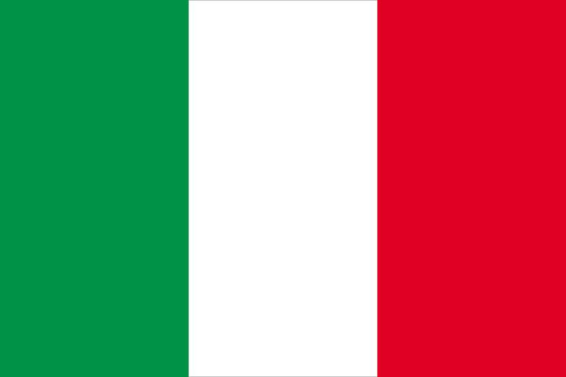
Committee: UNEP Country: Italy
Agenda Item: Enhancing the transition to sustainable energy as a response to the climate change.

Overview
Italy is a Mediterranean country with a vast coastline that has left an indelible influence on Western culture and food. Italy is located in southern Europe on the Apennine Peninsula. Italy's population is around 60 million. The manufacturing of high-quality consumer goods by small and medium-sized businesses, many of which are family-owned, is a major driver of the Italian economy. Italy also has a substantial subterranean economy, which accounts for up to 17% of GDP, according to some estimates. Our country’s current president is Sergio Mattarella.

Committee
The United Nations Environment Programme (UNEP), which was created in 1972, deals with environmental concerns on a global and regional scale for the UN. UNEP transitioned from a Governing Council comprising 58 Member States to an Environment Assembly that includes all 193 UN Member States.

Agenda
The agenda item of our committee is using sustainable energy as a response to the climate changes. Renewable energy is energy derived from non-depletable natural sources such as sunlight, wind, and hydropower. And, because these natural resources aren't going away anytime soon, using them to generate electricity is not only safe but also environmentally friendly. Furthermore, unlike the harmful consequences produced when fossil fuels are used for energy, these alternative energy sources do not often produce any negative byproducts.

Objectives and Resources
Italy has always agreed with the idea that using sustainable energy to produce energy. Italy is ranked third in Europe for both renewable energy consumption and renewable energy output . Italy is one of the countries that has met its renewable energy target of 10% of total energy consumption by 2020.
Possible solutions can be to educate everyone about how harmful it is to use fossil fuels instead of sustainable energy sources. All the countries should start using renewable energy in more ways possible instead of fossil fuels.

