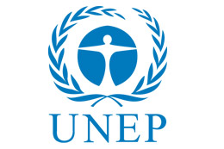
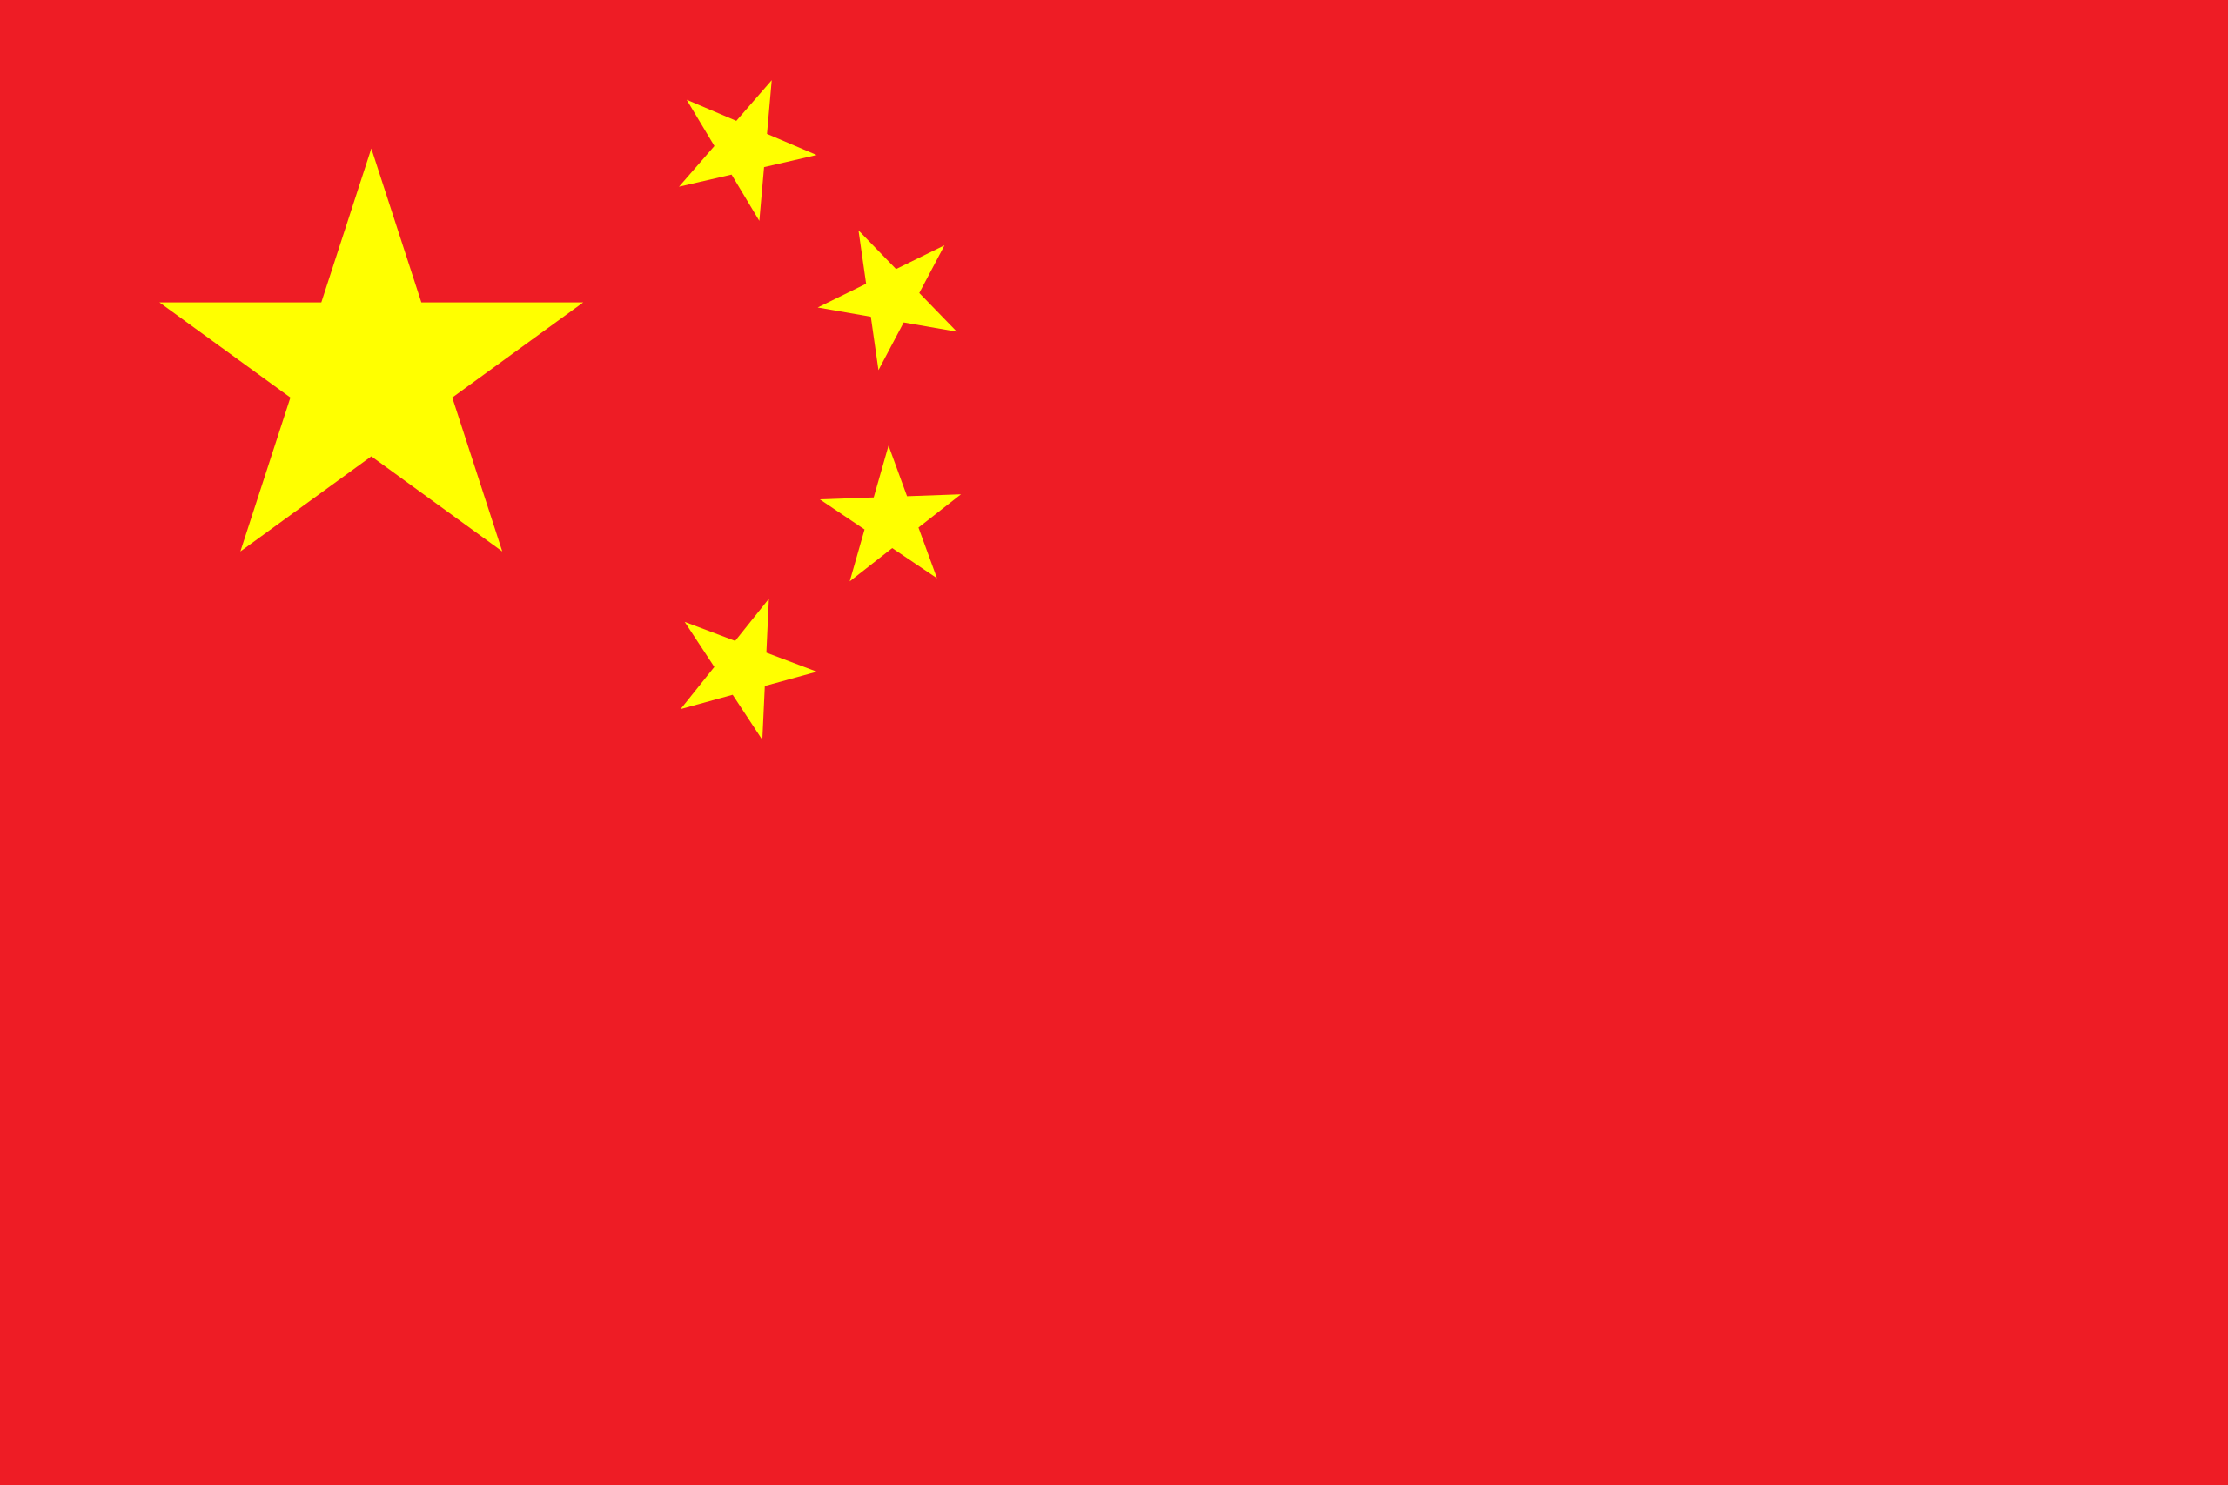
Committee: United Nations Environment Programme
Country: People’s Republic of China Topic: Sustainable Energy and Climate Change
I. Basic Information
People’s Republic of China (PRC), a nation located in East part of Asia. It’s on the coast of Yellow Sea, East China Sea and South China Sea. It holds a population of nearly 1.412 billion (2021), It’s the world’s most populous country. It is the world’s second largest economy with 17.72 trillion USD (2020) GDP rate and %5.5 percent unemployment rate. With the decreasing rates of COVID-19, China is recovering in every area. China is the world's leading country in renewable energy producing, total renewable energy capacity of China is over 1000GW (2021), 43.5% of It’s total power generation capacity.
II. Committee
United Nations Environment Programme (UNEP) was formed in 1972. It has been the global authority that sets environmental agenda, promotes the coherent implementation of the environmental dimension of sustainable development within the United Nations system and serves as an authoritative advocate for the global environment.
III. Committee Topic
The topic of our committee is sustainable energy, increasing the rates of using and producing energy from sustainable and green energy sources and depending to that, climate change and global warming. Energy means so many meanings to humanity and It has big priority and importance. People are producing energy from different sources but fossil fuels and sources like them are playing the biggest role in global warming and climate change. Because of this reason, humanity have to find new ways to produce energy if they want to be sustainable.
After COVID-19, people understood the importance of sustainable energy because of the pandemic. But after the last clashes between Russian and Ukrainian armed forces showed that independent, decentralized and sustainable energy is only and cheapest for energy and humanity. Gas and oil prices increased dramatically and this dragged countries to produce energy from sustainable energy sources.
IV. Objectives
As of one of the world’s biggest energy producer and user, People’s Republic of China, we are highly encouraged to work for our world and our future. Due to It’s geographical location and resources, China is always a supporter of sustainable energy and It aims to have 80% of its total energy mix come from non-fossil fuel sources by 2060. The delegate of People’s Republic of China will be coopeative and supportive to other delegates during each session of committee.
V. Expectations / Resources of People’s Republic of China
As People’s Republic of China, we are willing to whatever is necessary to improve our life standards and leaving a good future to our next generations. With highest capacities and high aims about sustainable energy, we are ready for fighting with global warming and climate change with all effects of them. Our grew and growing industry and manpower, we are highly encouraged for cooperation with UN and participant countries.
VI. Solutions
- People must be informed about the insensible and further effects of keep using fossil fuels for producing energy.
- UN and governments of countries must encourage people and investors for investing to sustainable resources.
- UN countries must follow the sustainable development goals (such as making cities more sustainable etc.).
- Countries with low GDP’s must be opened for foreign investors or UN for development in sustainable sources area.
- UN must be in a mediator role between Russian Federation and Ukraine in their clashes. These countries should realize the current and potential effects of these clashes on energy market and other industries.

Sources / References:
https://www.britannica.com/place/China
https://globalpeoservices.com/top-15-countries-by-gdp-in-2022/
https://sdgs.un.org/goals
https://www.worldometers.info/world-population/china-population/

