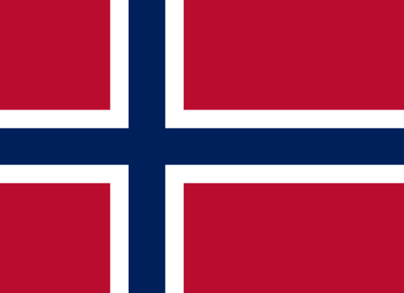
Committee: Historical North Atlantic Treaty Organization (H-NATO)
Topic: Ethnic Rivalry in North Macedonia Between 2001-2003
Country: The Kingdom of Norway

About Our Country
Norway, As It’s the official name The Kingdom of Norway, which is a Nordic country and located in Northern Europe. It has borders with Finland, Sweden and Russia. Norway has a total area of 385,207 square kilometers (148,79 sq mi). Norway is the fourth-largest country in Europe. Its population is 4,478,497 according to 2000 data. The capital and the largest city of Norway is Oslo. Also, Norway is a member of NATO.
The Issue and Our Country’s Point of View
The Kingdom of Norway is a member of the North Atlantic Treaty Organization (NATO) and in superb cooperation with other participants of NATO. Also, The Kingdom of Norway is responsive to issues of humanity in the world and respectful of the sovereignty of countries.
The ethnic rivalry in North Macedonia is an issue of humanity. The Kingdom of Norway and the other participants of NATO are responsive to issues of humanity. NATO is the pioneer contributor to universal peace, and it attempts to take steps towards this goal in the international arena. The ethnic rivalry in North Macedonia is an issue of humanity.
One of the reasons for ethnic tension is the cosmopolitan structure of North Macedonia. The ethnic structure in Macedonia is as follows: 64.17% are Macedonians, 25.17% Albanians, 3.5% Turks, 2.66% Roma, 0.48% Vlachs, 1.78% Serbs, 0.84% Bosnians and 1.04% belong to other ethnic groups. Nationalist movements of these ethnic groups can cause problems in this case.
Our Solution Ideas for This Issue
- Norway’s recommendation to political parties in North Macedonia is to work to ensure peace. Parties should wink about the benefits of the whole country.
- The Macedonian government should approach the NLA peacefully. And they should think of military operations as a second option to prevent casualties.
Norway has some recommendations to its allies in NATO:
- NATO forces should follow this conflict closely.
- NATO should provide support to the North Macedonian government.
- When necessary, military intervention should be made by taking care of civilians.
REFERENCES
https://delegatepal.com
https://knoema.com/atlas/Norway
https://en.wikipedia.org/wiki/Norway
https://en.wikipedia.org/wiki/Demographics_of_Norway
https://eacea.ec.europa.eu/national-policies/eurydice/republic-north-macedonia/population-demographic-situation-languages-and-religions_en

