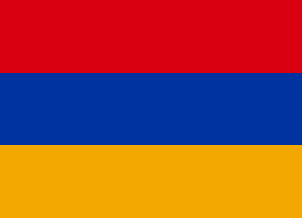
Country: Armenia
Committee: UNESCO-2
Agenda Item: Barriers to Education in Conflict-Affected Countries

Armenia, officially Republic of Armenia, is a landlocked country located in the Armenian Highlands of Western Asia. It is a part of the Caucasus region; and is bordered by Turkey to the west, Georgia to the north and Azerbaijan to the east, and Iran and the Azerbaijani exclave of Nakhchivan to the South. Yerevan is the capital and largest city. Armenian mines produce copper, zinc, gold, and lead. The vast majority of energy is produced with fuel imported from Russia, including gas and nuclear fuel; the main domestic energy source is hydroelectric. Small deposits of coal, gas, and petroleum exist but have not yet been developed. In education, a literacy rate of 100% was reported as early as 1960. In the following years, education continued to progress in this way.
Conflict-affected countries include over 20% of all children of primary school age, but account for around half of all out-of-school children of primary school age. The likelihood of young children dropping out of school is also significantly higher in conflict-affected countries than elsewhere in the world: only 65% of children in these countries attend the last primary school grade, in comparison to 86% across low-income countries. Research has highlighted in particular the causal adverse impact of conflict exposure in terms of reducing the number of years children spend in school, and restricting grade progression. These effects have been shown in turn to affect considerably future life prospects of affected children, including access to labour market, earnings and health outcomes in adulthood, which may aggravate risks associated with the outbreak or renewal of violent conflicts.
As a solution, we thought that all students in war-affected countries could be temporarily taken to another country for study until the country's war etc. finishes. They study and stay in that country until their problems are over, and then they return to their own country. In order to comply with this solution, an international agreement can be signed and thus secured. If this solution is not complied with or implemented, they may live in shelters in their own country, etc. After being secured at the venues, training is given there. In addition, some activities can be organized to improve the psychology of children affected by the war.

