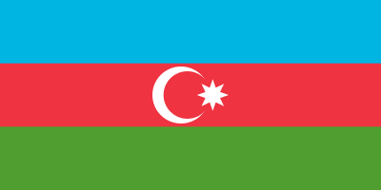
Country: Azerbaijan

Committee: WHO (World Health Organization)

Agenda Item: New Normal after the Covid 19 Pandemic and the Role of Vaccination

Azerbaijan is a country on the Asian Continent and Azerbaijan’s population is over 10 million. Azerbaijan has many rivers, extensive forests, natural resources, energy resources and agricultural lands, as well as very well-educated schools and, most importantly, hospitals with well-equipped doctors and health researchers. In Azerbaijan, there are over 800 hospitals and over 30.000 doctors are working. And the average age of death is 73.

The WHO Country Office, Azerbaijan was established in June 1994 in Baku to assist in the implementation of WHO programs in the country. With this application, Azerbaijan started to improve itself in health. In February 2020 WHO confirmed that Covid-19 is started to spread in Azerbaijan. Covid-19 has shown its effect in Azerbaijan for more than 2 years. It continues to show its effect, although not as much as before.

Sinovac which is the first vaccine was found on 17th January 2021. Then the Biontech on August 23th 2021. The effect of Covid-19 was reduced because of the vaccines. But that doesn't mean we can live like before Covid-19 anymore. The people of Azerbaijan were living like old normal. It is not true behavior. After Covid-19 we have to adjust ourselves to the new normal.

