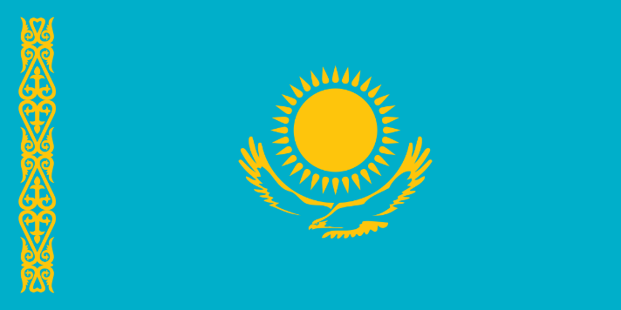
Committee: UNEP – United Nations Environment Programme
Topic: Climate Action
Country: Kazakhstan
Delegation: Selin ALTUN

Kazakhstan is a country that has wide selection of amazing flora and fauna. The development of the agrarian-industrial sector has a direct impact on the state of the natural environment. Sustaining agricultural productivity is increasingly challenged by climate change trends of altered precipitation patterns and growing seasons and increased risk from pests and diseases. The country is currently reforming environmental laws in order to take into account the balance between environmental, economic and social interests. Kazakhstan’s long-term objective is to become one of the first 30 most developed countries in the world by 2050 which undoubtably requires implementation of measures to reduce greenhouse emissions. In 2013, First President Nursultan Nazarbayev set an ambitious goal of achieving a 3 percent share of renewables for power generation by 2020, 30 percent by 2030, and 50 percent by 2050. Kazakhstan announced its intention to reach “carbon neutrality” by 2060 during the Climate Ambitions Summit in December 2020.
Kazakhstan’s climate is characterized as extreme continental, despite the proximity of the sea it’s very dry with hot summer and cold winters. The National Report of Kazakhstan concluded that the territory of Kazakhstan is warming significantly faster than the globe. The number of floods in the world increase about 6% annually which is observed in Kazakhstan as well. Kazakhstan, a major global wheat producer, suffered reduced crop yields from drought and fires. The floods cause significant economic losses. Abnormal heat and drought create several hundred wildfires that affect the population health.
The Aral Sea’s disappearance is considered one of the world’s worst environmental disasters. In the 80’s, The World Bank invested millions of dollars in a dam project to revive the Aral Sea. Due to the adverse ecological situation in the Caspian Sea, population of endemic commercial fish stocks have decreased dramatically, in particular the Caspian Sturgeon population which comprises 70% of the world stock. While Kazakhstan has a rapidly growing economy, rural population, farmers and pastoralists outside of the main urban centers face significant climate change risks to their livelihoods stemming from increased aridity, water management challenges and extreme weather events.
Kazakhstan has become rich by huge oil, gas, and coal reserves- in 2018 around 16% of Kazakhstan’s GDP came from oil revenues and in 2019, around 67% of merchandised exports were fuels. With its aging coal plants and transmission network, Kazakhstan is one of the world’s largest emitters of greenhouse gas emissions and, as of 2015, its energy sector accounts for 82 percent of the greenhouse gas emissions. In 2019, 90% of electricity was generated from fossil fuels; with coal accounting for 70% of electricity generation, and natural gas for 20%. These sources for electricity generation are complemented by hydro energy, which accounted for roughly 9% of electricity generation. Despite all the fossil resources, in 2016 the country ratified the Paris Agreement and has committed phasing out oil and coal, in favour of renewable energy. The country is as rich in renewable energy as it is in fossil fuels. Recently the largest solar powerplant in Central Asia opened in Kazakhstan. With more than 300 sunny days a year, the country could easily power itself on solar energy. In 2017 Kazakhstan spent billions of dollars on an exposition center to host an international forum on future energy.
Kazakhstan intends to achieve an economy-wide target of 15%- 25% reduction in greenhouse gas emissions by 2030 compared to 1990. In the 1990’s UNEP realized the importance of integrating sustainability into the global finance sector. Now UNEP Finance Initiative’s members include over 365 banks and investors; working with governments to invest in a sustainable future. Kazakhstan has resolved conflicts without choosing sides, promoting peace which has led the country to gain the trust of foreign investors. Kazakhstan aims to become more than just a bridge between Europe and China, it is expected to be the green superpower of the future. The Kazakh Government estimates that the transition to a green economy will be accompanied by substantial economic and societal benefits. By 2050, the transition is expected to create more than 500,000 jobs, develop new industries and improve quality of life
The Biodiversity Finance Initiative contributed by proposing legal regulations such as voluntary payments for ecosystem services, increasing the environmental responsibility of companies, development of sustainable transport, planning number of tourists and minimizing formation of solid waste.
It seems that Kazakhstan focuses too much on its capital, Astana. Kazakhstan is one of the largest countries in the world so only focusing on one city has led people living in other parts of the country to face unfair treatment. Kazakhstan should distribute funding equally across the country. For examples sea regions would benefit from better funding as fishing used to be a key industry in Kazakhstan. The government should pay attention to the water level in the Aral Sea, which is dropping again. Also, the government rarely funds its own “green developments”. They are reliant on private investors to fund their green revolution. The reason for this might be that the country doesn’t want to lose the big oil companies trust, as oil has been a main income source for the country. To resolve these issues the country must plan for a sustainable future instead of clinging on to profitable but harmful choices.

REFERENCES
WHO/Europe | Climate change - Kazakhstan
Energy and Environment | Kazakhstan | U.S. Agency for International Development (usaid.gov)
Kazakhstan | Global Climate Change (climatelinks.org)
INDC Kz_eng.pdf (unfccc.int)
Policies & action | Climate Action Tracker
Kazakhstan | UNDP Climate Change Adaptation (adaptation-undp.org)
The new green superpower? Oil giant Kazakhstan tries to wean itself off the black stuff - YouTube
Kazakhstan presented its nature-based solutions at the Nature for Life Hub 2021 - YouTube

