UNEP, DELEGATE OF SAUDI ARABIA, POSITON PAPER
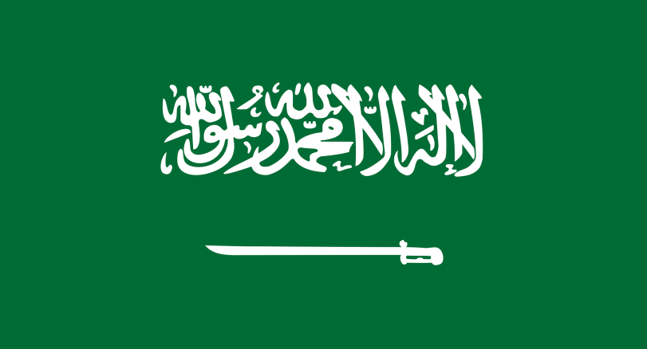
Name-Surname Bilge Öztürk
Committee: UNEP
Agenda Item: Climate Action
Country: The Kingdom of Saudi Arabia

The Kingdom of Saudi Arabia is a Middle Eastern country known for its oil reserves. Most of Saudi Arabia follows a desert climate with exceptions. Temperatures can reach over 110 degrees Fahrenheit in the desert in the summer, while in the winter temperatures in the North and central parts of the country can drop below freezing. Saudi Arabia gets very little rain, only about four inches a year on average. Saudi Arabia’s population is 35 million.

According to our Vision 2030, the contribution of renewable energy to the overall energy mix will reach up to 50% by 2030. The kingdom aims to reach Net-Zero by 2060. By protecting marine life and expanding key natural habitats through initiatives like marine spatial planning and turtle tagging, The Red Sea Development Company aims to deliver a 30% net conservation benefit by 2040 and a zero-carbon footprint by sequestering carbon from the atmosphere. Saudi Arabia aims to make its country more green and livable.

We think that we need to help developing countries take steps about climate change by providing money according to their economies and helping them make plans or projects. The developed countries should send teachers to developing countries to teach about climate change at schools. We need to inform people about climate change and its effects.

