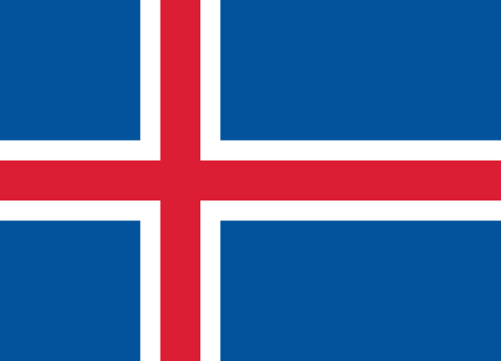
Conference: TEDUMUN
Committee: UN WOMEN
Topic: Elimination of the Raising Domestic Violence During Covid-19 Pandemic
Country: Iceland

Position Paper
The concept of women's rights gained great importance especially in the 19th century. Various institutions and organizations around the world are working to eliminate the problems and discriminations faced by women. Even today, incredible events are still happening, especially in the Middle East countries. Unfortunately, nations that see women as an object rather than a human still exist. They continue to torture women with their understanding of management.
Every year, "The Economist" examines the OECD's data and publishes indices that reveal the inequality between men and women in working life. Iceland ranks first among the countries with gender equality in its latest index. According to the "Global Gender Inequality Report 2021" data of the World Economic Forum (WEF), Iceland, which has always managed to stay at the top for 12 years, again ranked first in the gender equality index. The historical past of the country has a great importance in making our country the most egalitarian country in the world. It was thanks to the struggle of women that Iceland became the leading country in gender equality. 40 years ago, the Icelandic women's movement said "Enough is enough" against the wage inequality between men and women, and carried out the biggest strikes and actions in Icelandic history. On October 24, 1975, 90 percent of women in the country quit their jobs and took to the streets. In Iceland, which had a population of 225,000 at that time, 30,000 women took to the streets in the capital Rejkjavik. Protest demonstrations spread across the country. And of course, our country signed the Istanbul Convention and put it into effect.
In our opinion, equality should be achieved primarily in administration and politics. because women who are successful in administration and politics become role models, give other women faith and self-confidence, and destroy perceptions. The world's first female president came out of our country and from the day she was elected, we really started to make progress on equality as a country. Today, we have been the first in equality for 12 years. We believe that if the United Nations brings a law in this field to the headquarters of the countries, it will be very effective.

