Committee: Commission on the Status of Women
State: The Argentina’s government representative
Institution: Şahinkaya Science High School
Agenda: Assurance of equal pay for services of equal derivative values between men and women , extending the reach of echonomic leadership of women in developing countries and women’s involvement in global politics as a minotory

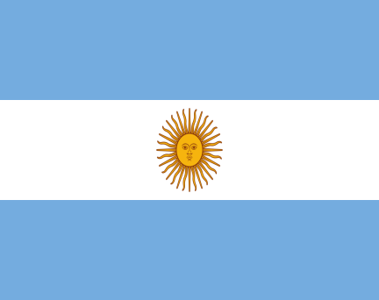

“The economy of a country relies on human capital. If you don't provide women with adequate health, education and job opportunities, you lose half of your potential. Gender equality and women's rights are the foundation of economic development.”
- Michelle Bachelet

In whole world there is a obvious lack of women rights stuation that everyone know but no one is trying to do something. There are stereotypes about women what makes everything hard for them even in 21st century.Like mothers can not be a good worker because she need to take care of her family or women can not do the things that man do. That kind of stereotypes efects women’s life badly and makes harder for them to find a proper job.If they can not find a job, societ’s base would get a hard hit because if women can not get money from somewhere, with one salary you can not make your children’s future certain because sadly even education needs money right now and with a one salary you could even bearly live so that would efects future’s society.

Let us think about a black or a latina women’s life, she discriminates because of her gender ,plus she discriminates because of her colour too.The researches about this topic says that black and latina women that only have bachelor’s earn 65% of what white men with only bachelor’s earn.This number is realy scary for our century.We should fix it as soon as possible.

Our country is trying to develop herself about women rights we can see that if we look 2019, the day when abortion became legal in Argentina. It was late but finaly women get their right that they deserved.The green fabric activists was opened the politicians’ eyes in 2019 and we hope that the countries which looks the women as a 2. type of human can open their eyes and minds to the women’s problems and hear their voice.Because this problem is realy important we are talking about half of the population.If we support them we could get our highest potential and the thing which one is more important, this is their right.You can not ignore half of your population you can not even ignore one person. Because as a human being everyone have a right to live and if you want to live you must work this is the rule of world. You can not say anyone “You can not work because you are a women so you must abide a man to work for you.”This is against to 14th item of Europian Convention on Human Rights Here it is“Benefiting from the rights and freedoms recognized in this Convention, sex, race, colour, language, religion, political or other opinion, national or social origin, affiliation with a national minority, property based on any other condition, particularly birth should be provided without any discrimination.”

.

