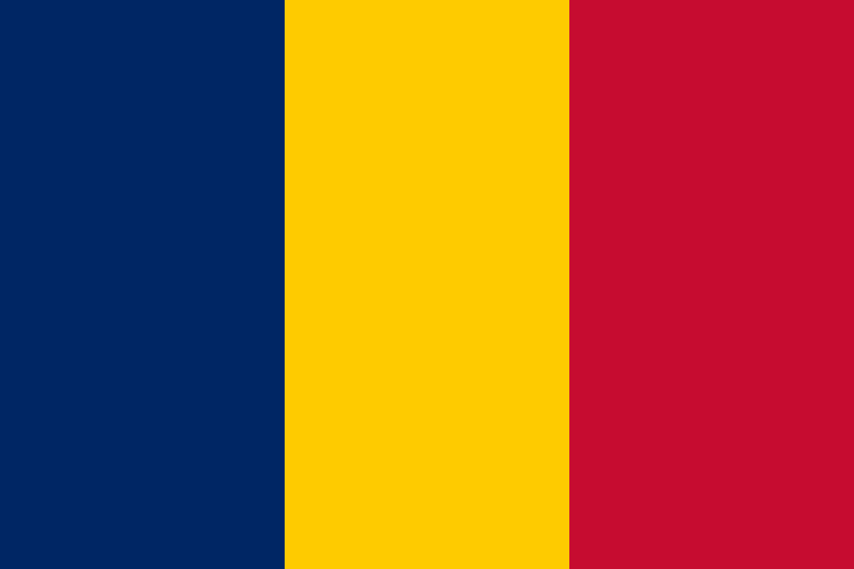
Country: Chad
Committee: UNODC (United Nations Office On Drugs and Crime)
Agenda Item: Money Laundering and Cauntering the Financing of Terrorism

Boko Haram is a terrorist organization which operates in Chad. Caught terrorists will be put on trial by Extraordinary African Chambers. Unfortunately, we lost President Debby during these terrorist acts. In this case, we received help from our ally, France.

Dozens of our citizens lost their lives as a result of Boko Haram actions. Necessary Unicef support was provided to vhildren affected by this attack. Besides Boko Haram, another problem is the increasing smuggling activities in Lake Chad. As a solution to the problem, we decided to increase waterways and coastal controls together with the EU. For this purpose, Frontchad was established as a tool for stability and peace.

Thanks to this project, we have increased inspections on Lake Chad and the Chasi Loyane river.As a result of this 18-month program, we opened the Compagnie de la Secwite Nountainie (CSN) station, which is the water police organization.with CSN, we increased the number of police from 78 to 333 and strengthened the coast security with 13 small boats.With CSN, we inspected the smuggled goods trade and seized the drugs that were tried to be smuggled into our country. We have seen how effective the CSN project is to combat organized crime.

