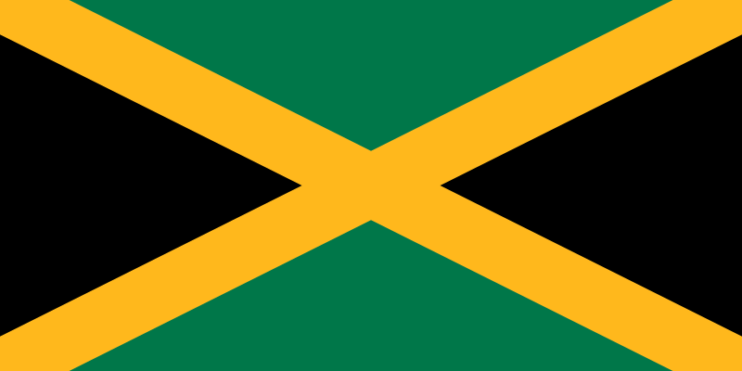
Country: Jamaica
Committee: UNODC (United Nations Office On Drugs and Crime)
Agenda Item: Money Laundering and Cauntering the Financing of Terrorism

Our country is the island country of the West Indies . It is the third largest island in the Caribbean Sea after Cuba and Hispaniola.
It is located on the Caribbean coast. Central America. Its national capital is Kingston.
Our country is a constitutional monarchy with a parliamentary system of government
The legal system is based on English common law
Consists of a bicameral parliament
Citizens who are at least 18 years old have the right to vote
The two main political parties are the Jamaica Labor Party (JLP) and the People's National Party (PNP).
Our country is developing by taking important steps in crime and drugs in military and police sense.
In addition to these developments, it cooperates with other countries, which shows that our country follows a conciliatory policy.
In addition, we are conducting investigations on crime and drugs with our eyes wide open. While we are progressing in the phase of catching important criminals, we are also preparing for the trial process after they are caught.

