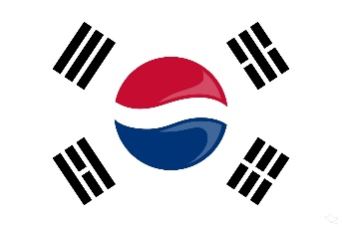
COUNTRY: SOUTH KOREA
COMMITTEE: CSW
AGENDA ITEM: SOUTH KOREA’S PERSPERCTIVE ON TRANSGENDER WOMENS
DELEGATE: EYLÜL ESRA ÖZEN
South Korea, officially the Republic of Korea, is a country in East Asia that forms the southern part of the Korean Peninsula and shares a land border with North Korea. The name Korea derives from Goguryeo, which was formerly one of the greatest powers in East Asia, and under the Greater Gwanggaeto ruled the Korean Peninsula, much of Manchuria, the Russian Far East, and parts of Inner Mongolia. Its capital, Seoul, is a major global city, and half of South Korea's more than 51 million people live in the Seoul Capital, the world's fourth largest metropolitan economy. Authoritarian rule ended in 1987 and the country now enjoys one of the highest press freedoms in Asia. South Korea is a member of the OECD's Development Assistance Committee, the G20 and the Paris Club.
Sex reassignment surgeries have been legal in South Korea since 2006. People over the age of 19 and with parental consent can have this surgery. Harisu is South Korea’s first transgender entertainer, and 2002 became the second person in south korea to legally change sex. In august 2007, the supreme court ordered the government to allow Beyond the Rainbow an lgbt rights foundatin, to register as a charity with the Ministry of Justice. Without official registration the foundation was unable to receive tax deductible donations and operate in full compliance with the law. In 2004, the South Korean Government voted in favor of a United Nations resolution aimed at combating discriminaction against LGBT people. As the state of south korea, we believe that every person should live in the body they feel free and no one should be judged for their sexual identity or sexual orientation. Former head of the korea LGBT Human Rights Solidarity Lim Tae – hoon ;they need quite a bit of money to have gender reassigments surgery, but the inconsisteny between their citizen identification number often makes it difficult for them to find decent jobs, the last option for them is to work in dark bussiness to earn money for surgery. The UCLA of law wiiliams institute conducted in 2019 surveying Korean citizens to gauge public opinion of transgender rights in South Korea. According to the survey, ‘ a mojorty supports access to gender affirming surgery, the right to conveince or give birth to children, government protection from discrimination, and the right to serve in the military’ The South Korean State has taken great steps to overcome transphobia, which has been a common problem for the whole world for a long time.
On behalf of the South Korea government, I would like to final statements. As South Korea delegate, As South Korea, we have taken great steps to defeat transphobia and we will continue to do so. Trans women are women. Every person should live the way they feel, and we recognize the importance of that

