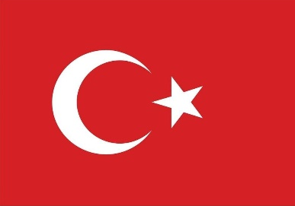
Country: Turkey
Committee: UNEP - United Nations Environment Programme
Agenda Item: Climate Action

Turkey, officially the Republic of Turkey, is a transcontinental country located mainly on the peninsula of Anatolia in Western Asia, with a smaller portion on East Thrace in Southeast Europe. Turkey has a significant geostrategic power as it is located at the crossroads of Europe and Asia. Turkey is a democratic, secular and unitary constitutional republic governed by a presidential system. Its official language is Turkish, which is the native language of 85% of the population. Today, Turkey is considered a regional power thanks to its growing economy, military capacity and diplomatic initiatives.
Turkey's annual and maximum temperatures are rising, and 2020 was the third hottest year on record. Turkey will be greatly affected by climate change and is already experiencing more extreme weather, with droughts and heatwaves being the main hazards. Current greenhouse gas emissions by Turkey are about 1% of the global total. As Turkey; we are aware of the fact that climate change is a multifaceted and complex problem that can lead to very serious environmental and socioeconomic consequences and even threaten the security of countries, and that the effects it will cause have become one of the most important tests that threaten the lives of future generations. We are aware of the importance of international cooperation within the scope of reducing greenhouse gas emissions that cause climate change and combating climate change In this context, Turkey has prepared the "National Strategy for Adaptation to Climate Change" in order to contribute to the global efforts to reduce the effects of climate change, within the framework of its own special conditions and possibilities. Turkey became a party to the Montreal Protocol on 19 December 1991 and accepted all its amendments. It is about the treaty was about restricting chemicals that damage the ozone layer, impacting greenhouse gas emissions. Turkey is among the most successful countries in the implementation of the Montreal Protocol. Turkey became a Party to the Kyoto Protocol on 26 August 2009. The nations that signed the treaty pledged to reduce emissions by %5 on average between 2008 and 2012 and each country varied in its targets. Turkey signed the Paris Agreement on April 22, 2016. The Paris Agreement has the aim to combat climate change and adapt to its impacts and their direct and indirect consequences. Reducing greenhouse gas emissions and limiting global temperature increase to 1.5 °C, at a maximum 2 °C above pre-industrial levels.
Many actions can be taken to move forward in solving this issue and provide the improvement in as many govermnets as possible in the World. One of them is to prepare a new protocol. Greenhouse gas emissions are increasing every year. And other prepared protocols are obsolete. And not all countries fully comply. Thanks to this new protocol, these can be fixed.

