Country: | Sri Lanka
Committee: | World Health Organization
Topic Area : | Responding to the Opposition to Vaccination
Delegate: | Gül Semra Yoğun
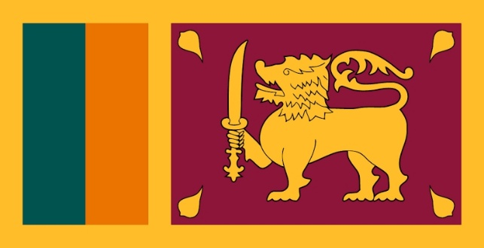

Covid has been one of the most fatal pandemic in the world for almost 2 years. As we all know, according to data published for months, people can die if infected with the covid-19 virus. According to the data published on December 4, 2021, 5.24 million people lost their lives due to the corona virus, and 265 million cases were detected.
In every period of history, the solution to epidemics such as the corona virus has been a vaccine. Considering the change in the incidence of a disease over the years, it is unmistakably seen how effective the vaccines are. For example, although there have been periodic ups and downs over the years, the actual permanent decline in measles incidence coincides with the licensing of the measles vaccine in 1963 and the widespread use of the measles vaccine.
As Sri Lanka, 62.7% of our people have had 2 doses of vaccine and 72.7% have had at least 1 dose of vaccine.
Having the disease creates as much immunity as being vaccinated. However, gaining immunity by contracting the disease itself rather than being vaccinated can have heavy costs. For vaccines, products of the healthcare industry are monitored by the practice team, as well as by the vaccine practice (World Health Organization, CDC schools) and healthcare personnel. There are vaccine side effect tracking systems working hard all over the world and vaccines are followed much more closely due to side effects.
Sri Lanka also believes ıf we want to get rid of this disease as the whole world, the only solution is vaccination. Otherwise, we cannot cope with this disease without gaining immunity. If we do not react to the opposition to the vaccine, this virus will cause many more people to die.

