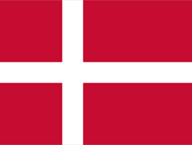
Country : Denmark
Committee: WHO –World Health Organization
Agenda Item: Responding to the Opposition to Vaccination

Denmark is a Scandinavian country in Northern Europe. Located in the southernmost of the Scandinavian countries, most of Denmark is on the Jylland peninsula. Denmark, officially the Kingdom of Denmark, the country's form of government is a “constitutional monarchy”. The official language is Danish, which is the main language of the population. Danes have a high standard of living, and the country ranks high in some national performance measures, including education, health care, civil liberties protection, democratic governance, and LGBT equality. It is among the founding members of NATO, the Nordic Council, the OECD, the OSCE and the United Nations. It is among the developed countries with dec strong economy.
Denmark was among the first European countries to implement decantment measures. We believe that we should do our best to protect the health of our citizens during the Covid-19 period.
We consider vaccination to be one of the most effective, economical and reliable methods of protecting society against infectious diseases. Since the introduction of vaccines, the incidence of infectious diseases has decreased, and significant contributions have been made to the prevention of deaths from infectious diseases. Vaccination is a rather necessary action nowadays.
As Denmark, we have informed our people about the importance of the vaccine with simultaneous vaccination campaigns and encouraged the vaccine together with media outlets. Since the start of my coronavirus vaccination in Denmark, 83% of our population has been vaccinated in two doses. As of September 10, all Covid-19 restrictions have been lifted in our country and we have completely contained the epidemic.

