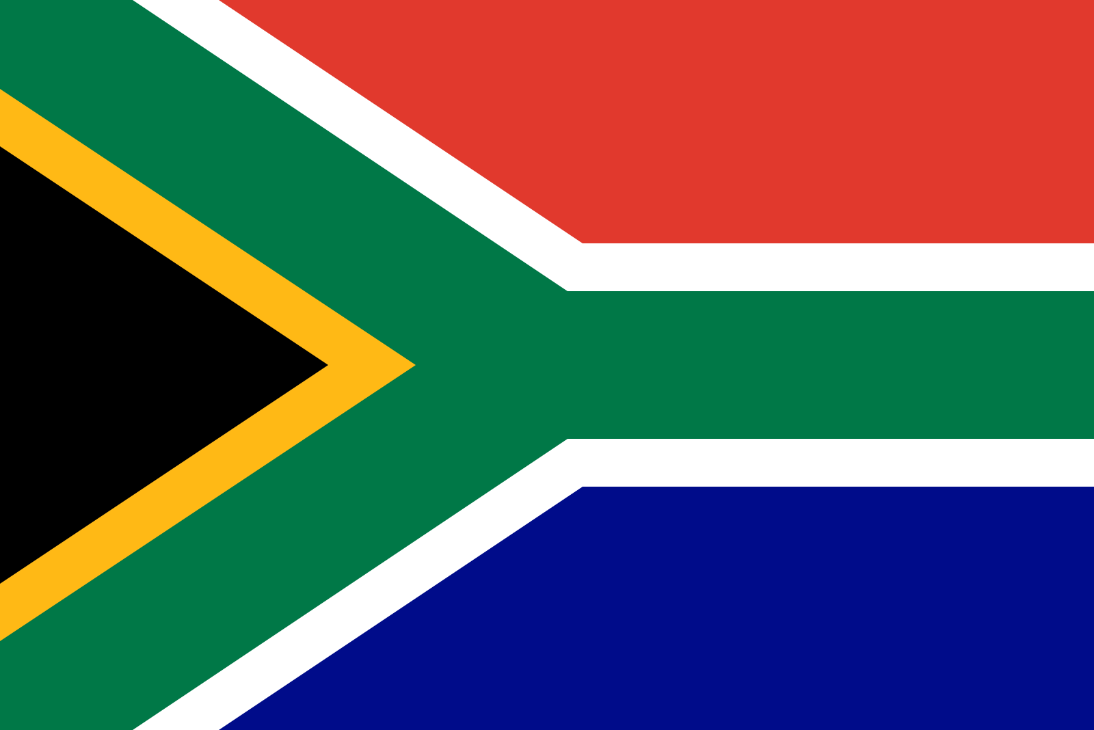

Name, Surname: Mehmet Orkun Apaydın
Committee: UN Women
State: Republic of South Africa
Agenda: Domestic Violance and rights

We as a The republic of South Africa state that domestic violance and women rights in political, social and other areas in social life are most important issues in the world. In most of countries, women has been trying to have rights in terms law and avoid from domestic violance by men. Moreover, during COVİD-19 pandemic violance aganist women has increased and it demonstrates us women rights’ importance. However, even if law regulations are expelled by goverments, applications of these regulations are not effective. That’s why, we believe that UN Women’s role is very determine to overcome this problem.

We care domestic violence and women rights because, in most of the societies, system which puts forward men does not give opportunity to women like men to live freely and COVID 19 pandemic made life harder for them.In our country, domestic violence is very important issue because we have high violence statistics, so we are planing regulations in terms of security and we has been deceasing cases of violence against women. Also, as our president announced, we are going to establish special courts and we are going to pass new laws in terms of women rights in social life. So we seek to decrease numbers of violance cases.

We have some recommodations to UN Women to solve this problam globally and we suggest that UN Women should have committee which is accepted by all countries which are candidates of UN and committe should have policy. Within this scope, committe offer these countries that if a country have regulations about women rights in terms of political, social and law, committee will give them economic incentives, so with this policy women will be protected and they will be important part of society. However, committee should control regulations and datas carefully to pretend incorrect datas.

