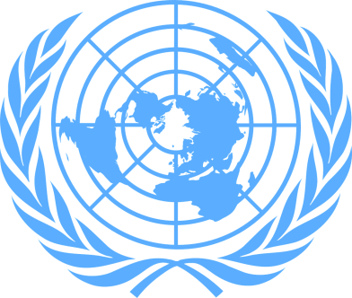
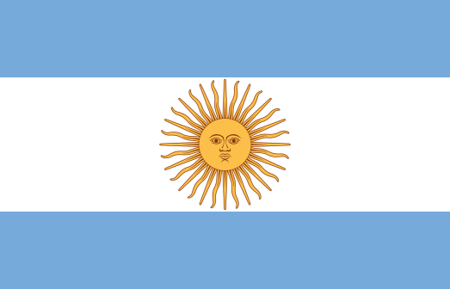
Recognition and Visibility of Transgender Women

Country: Republic of Argentina
Committee: The Commission on the Status of Women (CSW)
Delegate: Göktuğ Beken Ardıç

Trans women are excluded in most countries due to a judgment from the past. Although there are countries where trans women are excluded by governments, usually this exclusion is made by society.
As a delegate of Argentina, we want trans women to live freely, to be able to enter business life and to be evaluated as human beings, not as trans individuals. Our work in this field:
1. In 1997, the Asociación de Lucha por la Identidad Transvestite-Transgender was founded to defend the rights of trans people. One of his first victories came in 2006, when the Supreme Court overturned a lower court ruling that said trans people had no legal right to organize and campaign for their rights.
2. In 2007, the Supreme Court ruled that a 17-year-old child has the right to undergo a sex change process and change his legal documents to reflect the operation.
3. The Gender Identity Law, adopted in 2012, allowed Argentina to "allow people to change their gender identity without encountering obstacles such as hormone therapy , surgery or psychiatric diagnosis.
4. In mid-2018, the cities of Rosario and Santa Fe, Santa Fe Province, included several trans people in the Historic Repair program, which provides pensions to victims of the last military dictatorship.
5. On June 18, 2018, a Buenos Aires court sentenced Gabriel David Marino to life in prison for the murder of transgender activist Diana Sacayán. For the first time in history, an Argentine Justice has acknowledged thaat the murder was a "hate crime against the identity of a transvestite" and is known as a "travesticide" or "travesticide".

There are only 5 of them here. Argentina has reduced discrimination in society with these studies and considers everyone to be human.

