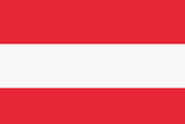

POSİTİON PAPER

**Committe:** **United Nations Office on Drugs and Crime**

**Topic:** **Money Laundering and Countering the Financing of Terrorism**

**Country: Austria**

Name: Nisa Alkan

Austria is not among the 39 countries in the Fatf's gray and black list. But Austria ranks 15th among the countries with the most black money. Austria has an annual source of $20.231 billion in black Money.

And Austria ranks 17th among the 20 countries with the most money laundering. . Austria has an annual source of $48.376 in black Money. The amount of money laundering from the Netherlands to Austria is 187 million dollars. Austuria has 497 points in the black money flow attractiveness ranking.(If the attractiveness score is high in the of that country it shows that there are deficits in the face of money laundering)

There are a lot of organizations established in connection with the reduction of money laundering.Firstly FATF was established in 1989 by the G7 countries within the OECD (USA, Japan, Germany, France, UK, Italy and Canada) in order to prevent international money laundering. FATF continues to cooperate with some international organizations to effectively combat money laundering and terrorist financing. These organizations are; CFATF,EAG,ESAANLG,MONEYVAL,GAFISUD,GIABA,MENAFATF and APG

Our solution proposals; States should cooperate, strengthening of agreements between states, increasing audits and social media platforms should be in cooperation with states.