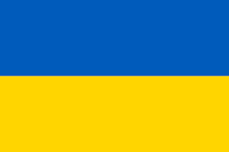
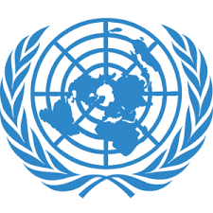
Committee: UNESCO
Country: Ukraine
Agenda Item: Climate change education, training and public awareness

Ukraine is a country which is located entirely in Eastern Europe in 603,550 sq km area and bordering the Black Sea. Ukraine is between Poland, Romania, and Moldova in the west and Russia in the east. The capital city of Ukraine is Kiev. Sixty-Seven percent of population speak Ukrainian and Thirty percent of people speak Russian as their first language.
As a delegate of Ukranie, Ukraine is aware that climate change has become an important problem especially in recent years. Our country has doing various projects aiming at solving the problem.
We all know that the use of solid fuels pollutes the air and this causes Global Warming. Global Warming has a big effect on climate change. At the conferences held in our country, it was concluded that it is necessary to reduce the use of solid fuels and instead, increase the use of renewable energy sources (such as solar energy, wind energy) and electric energy.
Our country will carry out studies to restrict the use of solid fuels and invest more in renewable energy sources. Moreover, our country will create funds for clean energy sources from next year's budget.
In this regard, what we need to do as a person is to use resources such as water and electricity sparingly. We should also use environmentally friendly products to reduce global warming. We should keep our environment as clean as possible and make people aware of this problem.

