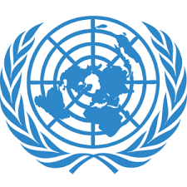
Delegate: Alkan Oydemir
Country: Thailand
Committee:UNESCO
Agenda Items: Climate change education, training and public awareness

Thailand historically known as the king of Thailand, its capital is bangkok, is a Southeast Asian country located in the central part of the Indochina peninsula. It borders Myanmar to the west, Cambodia to the east, Laos to the north, and Malaysia to the south. To the south is the Gulf of Thailand and to the west is the Andaman Sea.

Climate change causes heat. Although these changes occur spontaneously, they have been produced by humans for a long time. In order to be affected less by climate change in Thailand, they decided to use electricity. Here are a few of the results of the conference in the capital: It is stated at this conference that they can protect the climate if they adopt policies that will reduce emissions worldwide by 2030. It is also known that the consumption of carbon-based fuels has increased. Working to be affected less by climate changes in the world like; installing solar panels for the countries, conferences to assess climate change in Egypt, institutes established so these projects are to increase renewable resources and make the future good. Thailand's goal is to reduce its emissions by 20-25% from normal by 2030. Adequate water using measures such as growing plants and filtering factory pipes are important to Thailand.

For us just making a project is useless because people should learn this problem, for the people who cut a tree should need to be punished. To solve this problem is to provide electric vehicle assistance to the people living there. In addition, each person who buys a house can plant 4 trees per person living in the house and in this way climate change can be prevented.

