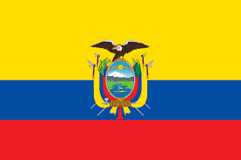

Country: Ecuador

Committee: UNESCO-2

Agenda Item: Barriers to Education in Conflict-Affected Countries

Our country is located in South America. And our capital city is Kito. The Republic of Ecuador is a republic governed by a representative democracy in South America. It borders Colombia to the north, Peru to the east and south, and the Pacific Ocean to the west. Located in the Pacific Ocean, 965 kilometers west of the mainland, the Galapagos Islands are also within the country's borders.

Primary education is free and compulsory for six years, starting at age six. Ecuador has made progress in making education available to the disadvantaged classes, ethnic groups and women. Religious and non-denominational private schools also play an important role.

Leading to better job opportunities for young people at greater risk of poverty and reducing the prevalence of adult income poverty — failure in education can reinforce this: a significant minority of students in several OECD countries do not even complete compulsory education; lower secondary students' test scores are strongly shaped by family characteristics; and the expansion of college education has often benefited households with better-educated parents. Aside from "equalizing" opportunities, education can be a powerful driver of social selection. When returns to education increase over time, this can lead to greater persistence of intergenerational poverty and less equal opportunity.