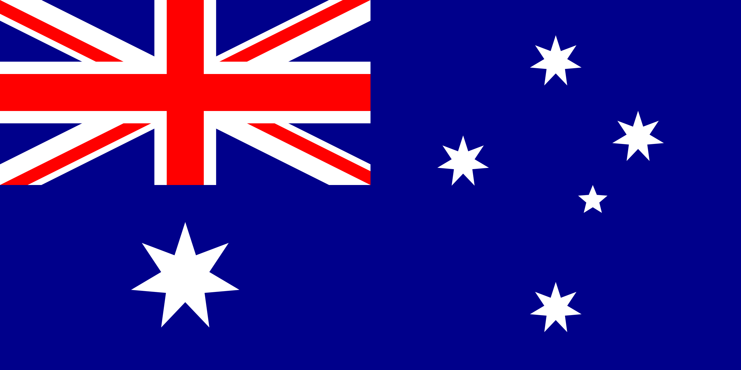
Country: Australia
Committee: UNICEF
Delegate: Alkan Oydemir

Honourable chair, Fellow delegates, Distinguished guest:

Australia is located in the Continent of Oceania and covers more than half of the continent. Australia's largest city is Sydney and its capital is Canberra. The Australian people, on the other hand, have a very humanistic and helpful nature. The language spoken in most of the country is English, but the Aborigines, known as the natives of the country, speak their indigenous language. Australia borders Indonesia, Papua New Guinea, Solomon Islands, New Zealand, Vanuatu, New Caledonia and East Timor. The country is also home to 6 major states.These are;New South Wales, South Australia, Tasmania, Victoria, Queensland, Western Australia. Australia has a wide variety of climates due to its large geographic size. Most of Australia is desert or semi-arid. Only the southeast and southwest corners have a temperate climate and moderately fertile soils. The northern part of the country has a tropical climate ranging from grassland to deserts.

