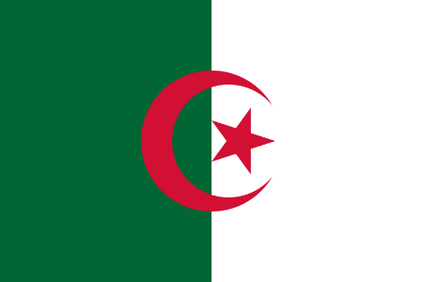 Country : Algeria
Comitee : UNWOMEN
Topic : Gender Related Mobbing

Position Paper
With a population of 44 million, Algeria is the ninth-most populous country in Africa, and the 32nd-most populous country in the world. There are 22.54 million males and 22.07 million females in Algeria. The percentage of female population is 49.48% compare to 50.52% male population. Algeria has 0.47 million more males than females. Algeria is at 162nd position out of 201 countries/territories in terms of female to male ratio. Algeria covers an area of 2,381,741 square kilometres (919,595 sq mi), making it the world's tenth largest nation by area, and the largest nation in Africa. From 1965 to 2022 Algerian women have fought for 57 years for equality. As in the most of the muslim countries have issues with women discrimination also in Algeria. When documenting great historical moments, women’s contributions have been decreasing from historical accounts. In addition, historical reports have often depicted women as the weak link rather than leaders and agents of change in their societies (Brownlee, 2017). This discriminatory heritage has been entrenched in the cultural, social, economic, political, and legal aspects of Algeria (Khanna, 2008; Moghadam, 2003). Algerian women relentlessly fought for their rights and stood up against oppression throughout the years (Moghadam, 2003); however, they still have a long way to go to achieve equality and social justice (United Nations Development Programme (UNDP), 2016; World Economic Forum, 2018). Despite the gender digital gap, women in the MENA region sought social media platforms to act as agents of change during political upheavals (Gheytanchi & Moghadam, 2014; Radsch & Khamis, 2013; Tufekci & Wilson, 2012). The Office National des Statistiques (ONS) (National office of Statistiques) (2017) reported that half of Algeria's population is under the age of 30. With women representing half of the population, their participation in the protests was highly noted (Mas, 2019). UN Women is the United Nations entity which strives effortlessy to promoting gender equality and the empowerment of women making it a global champion for women and girls, UN Women was established to accelerate progress on meeting their needs worldwide. In July 2010, the United Nations General Assembly created UN Women which cleary makes it an Entity for Gender Equality and the Empowerment of Women. In doing so, UN Member States took an historic step in accelerating the Organization’s goals on gender equality and the empowerment of women (United Nations. 2010-01-06).

