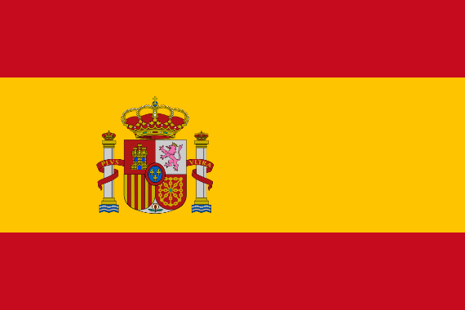
UNITED NATIONS OFFICE ON
DRUGS AND CRIME
Country: Spain
Delegate: Mehmet Berkay Meler
Topic: Money Laundering and Countering the Financing Terrorism
Money laundering is a serious threat to financial security. It has devastating consequences for the financial system and national security as it funds terrorists, drug traffickers, arms dealers and criminal groups. Money laundering also adversely affects economic growth by damaging the productivity of the country.
Spain accepted money laundering as a crime in 1988 in order to prevent money laundering from the drug trade. Changing money laundering methods and technologies overtime required some changes to be made in methods of struggle. Spain expanded the scope of money laundering crime and increased the penalties with the amendments made in the laws in 1995 and 2003. With the Royal Decree in Spain, Spain brought obligations to financial institutions such as "know your customers", detecting suspicious transactions, and keeping customer records for at least 5 years in 2005.
Spain proposes two possible solutions that the UNODC can execute. The first possible solution is to track payments to prevent online money laundering. In this way, the delegate of Spain envisages an understanding of where and by whom the illegal money comes from and for what purpose it is being used. The second possible solution is increasing the demand for credit cards and online banking by reducing the use of cash in order to facilitate the tracking of payments.
In conclusion, Delegate of Spain does not see online payments and cryptocurrencies as assisting bodies to money laundering attempts but Spain is aware of the danger if it is not well arranged. And Delegate of Spain thinks that a good step in the fight against online money laundering will be taken if the money is followed from where it comes from and for what purpose it will be used.

