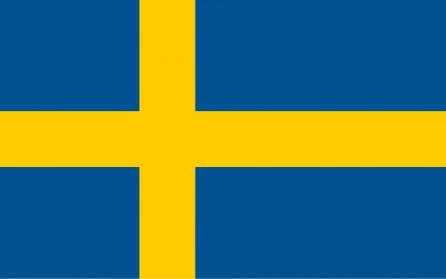
Country: Sweden
Committee: DISEC
Agenda Item: Weaponization of Data and Cybersecurity
SWEDEN
Sweden is a Scandinavian nation with thousands of coastal islands and inland lakes, along with vast boreal forests and glaciated mountains. At 450,295 square kilometers (173,860 sq mi), Sweden is the largest country in Northern Europe, the third-largest country in the European Union, and the fifth largest country in Europe. The capital and largest city is Stockholm. Sweden has a total population of 10.4 million, Its principal cities, eastern capital Stockholm and southwestern Gothenburg and Malmö, are all coastal. Stockholm is built on 14 islands. It has more than 50 bridges.
In Sweden, the growing awareness of potential threats among businesses and government
presents a dynamic business environment for cyber security technologies. Sweden is one of the most well-connected countries in the world with over 93 percent of the population having access to internet. The Swedish government launched a national strategy for cyber security in 2017 with several strategic areas, among them the enhancement of incident prevention capacity and systemic security. With the overall increase in IT security awareness, the new strategic and regulatory framework, and the government’s pledge to continue the improvement of Swedish cyber security capabilities, public sector investment in this area is expected to continue to increase. To provide security, government agencies are required by law to report IT security incidents. Copyright infringement is subject to the penal provisions pursuant to the Swedish Copyright Act and punishable by a fine or imprisonment for up to two years. Sweden’s government and national security leaders are pursuing a more aggressive, capital-intensive programme to scale-up spending and strengthen the Nordic country’s long-term capacity to defend itself against potentially damaging attacks from cyber terrorists and cyber crime organizations. cyber attacks posed a very real and immediate threat for Sweden’s economy and society. The protection of national critical infrastructure, such as public transport systems, telecommunications networks and power plants, will constitute a fundamental focal point in the Swedish government’s all-inclusive mission to deliver a more effective overall defense against future cyber terrorism threats. Sweden is taking new and future threats in the cyber domain is plainly visible in the government’s budgeting plans. Sweden plans to increase expenditure on its signals intelligence and cyber domain defence capabilities Sweden has become the latest Nordic country to bolster its cyber defence ambitions and capabilities in the face of heightened threats, with the government commissioning key defence and security agencies to establish a national cyber security centre.

BIBLIOGRAPHY
- https://www.computerweekly.com/news/450432739/Sweden-steps-up-cyber-defence-measures?amp=1
- https://en.m.wikipedia.org/wiki/Sweden
- https://iclg-com.cdn.ampproject.org/v/s/iclg.com/practice-areas/cybersecurity-laws-and-regulations/sweden/amp?amp_gsa=1&amp_js_v=a9&usqp=mq331AQKKAFQArABIIACAw%3D%3D#amp_tf=From%20%251%24s&aoh=16548088492484&referrer=https%3A%2F%2Fwww.google.com&ampshare=https%3A%2F%2Ficlg.com%2Fpractice-areas%2Fcybersecurity-laws-and-regulations%2Fsweden
- https://www.britannica.com/place/Sweden

