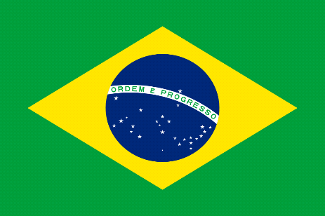

COMMITEE: Unwomen
Topic: Elimination of the Raising Domestic Violence During Covid-19 Pandemic
Country: Brazil
School: Aselsan Technical and Anatolian High School

According to topic the UNWOMEN committee two gender must have equal rights, responsibilities and opportunities many men have a chance to speak more than women, in world parliaments women have %24 percentage. The United Nations Gender Equality and Women's Empowerment Unit (UN Women's Unit-UN Women) is the United Nations agency that works towards achieving gender equality and empowering women. Established to meet the needs of women and girls around the world more rapidly, UN Women works jointly with the governments of UN member states, non-governmental organizations, and the private sector to design laws, policies and programs to achieve gender equality and to implement global standards in this field. executes. Advocates globally for the rights of women.

For many years, the United Nations faced serious challenges in its efforts to promote gender equality globally, including inadequate funding and no single recognized driver to direct UN activities on gender equality issues. In July 2010, the United Nations General Assembly created UN Women, the United Nations Entity for Gender Equality and the Empowerment of Women, to address such challenges Beijing Declaration and Platform for Action (PFA). Adopted by governments at the 1995 Fourth World Conference on Women, this document sets forth governments’ commitments to enhance women’s rights. UN Security Council resolution 1325 on women, peace and security (2000) recognized that war impacts women differently, and reaffirmed the need to increase women’s role in decision-making with regard to conflict prevention and resolution.

The Covid-19 pandemic has reversed the progress made so far on gender equality and the rights of women. To regain this loss, may take years. Inequalities for women are increasing during the pandemic in all areas from health, economy, security to social protection. The UN Secretary-General has mentioned “Limited gains in gender equality and women’s rights made over the decades are in danger of being rolled back due to the COVID-19 pandemic,” in April 2020. Markets and businesses closed because of the covid-19 pandemic, and it caused millions of women's jobs to disappear domestic violence (DV) is not a new concept. Throughout time, people have encountered this problem. However, DV cases increased during the Covid-19 pandemic and lockdowns. Between March 2019 and March 2020, The Crime Survey of England showed that 1.6 million women and 757,000 men had experience domestic abuse.

In Brazil, after the feminist movement (from 1960 to 1980), the number of domestic violence prosecutions had increased. However, only at the end of 2006 did Brazil pass the Maria da Penha Law, which provides legal protections for DV. The law represented an important achievement for women and a significant advance on previous Brazilian legislation for combatting domestic and family violence against women. Although legislation concerning violence improved, Brazil still ranks seventh in world with the most female homicides. About 4,465 female homicides occurred in 2010 in Brazil. Given Brazil’s size and socio-cultural diversity, there are also significant regional differences in the distribution of violence across the country. However, few studies have analyzed the distribution and variation of DV throughout the country.

Domestic violence means also called ‘’domestic abuse’’ can be defined as a pattern of behavior in any relationship that is used to gain or maintain power and control over an intimate partner. Abuse is physical, sexual, emotional, economic, or psychological actions or threats of actions that influence another person. This includes any behaviors that frighten, intimidate, terrorize, manipulate, hurt, humiliate, blame, injure, or wound someone. Domestic abuse can happen to anyone of any race, age, sexual orientation, religion, or gender. It can occur within a range of relationships including couples who are married, living together, or dating. Domestic violence affects people of all socioeconomic backgrounds and education levels.

There are four deaths of women per day. In 2006, the Maria da Penha Law (MPL) introduced integrated polices and transformed criminal procedures to deal with the complexities of gender violence. Reforms included the establishment of The House of Brazilian Women, women‐only police stations, specialized courts, intervention orders, interdisciplinary experts, and perpetrator programs. In 2015, a new law created the crime of femicide, designed to prevent ‘honor killings’ defenses in cases of intimate partner homicide and to avoid impunity. Despite law reform, structuring and articulating the network of services remains a challenge. The MPL led to great social change in Brazil regarding awareness of the violence against women, facilitating a broader discussion about gender equality.

As Brazil, we plan to do more for women's rights and we want the Istanbul Convention to spread to wider countries for this. In addition, as Brazil, we want to increase job opportunities for women, and we plan to open education academy for this.

