**Committee**: **The Social, Cultural and Humanitarian Committee** **(SOCHUM)**

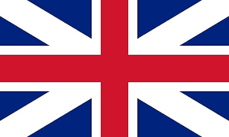**The Delegation of the United Kingdom of Great Britain and Northern Ireland**

**Topic:** **Refugee smuggling and rights**

**Delegate:Simge Çetintaş**

Our country, UK is one of the most important country in Europe. Even we are similar with our neighbors, our country has very unique differences. We known with our tea lover people, our football , history and culture.

Our democracy journey starts in 1215 with Magna Carta. With that, 25 barons who signed the contract can go against kings decision. With that, in dark medieval age, first time a kings power restricted in a council named Magnum Concilium. In time, it become parliament.

The second important event in our democracy history is Bill of Rights in 1689. The English Bill of Rights is a human rights declaration published in England in 168 9 that limits the arbitrary behavior and powers of the king of England. With this declaration, the kings who came to the throne in England have transferred most of their powers to the parliament.

Refugees and asylum seekers are at risk of exploitation,trafficking and modern slavery.This can often involve experiences of mental,physical and sexual violence.As a healthcare provider,you may be well-placed to identify people who have been trafficked and help them to access specialist support.

At first fort he human rights.The more people participating in a country’s economy the better.Economic activity alone is one of the many benefits of taking in refugees.There is an initial investment required when allowing refugees into a country.Housing,language classses,healthcare,sustenance.

According to UNHCR statistic,as of mid-2021 there were 135,912 refugees,83,489 pending asylum cases and 3,968 stateless person in the UK.