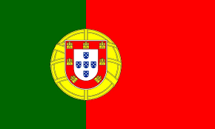

Committee: World Health Organization (WHO)
Topic: Responding to the Opposition to Vaccination
Delegation: Portugal
Delegate: Asrın Tunalı

As we all know one of the most important issue of our world is COVID-19 and the world is found COVID-19 vaccine. We take into account vaccination is one of the most effective ways to protect our families. First of all we can start the history of vaccine.
In 1796, Edward Jenner developed the idea of 'Cowpox' or 'Vaksinia', the first live viral vaccine, a scientific breakthrough in medicine and established the foundations of modern immunology. It was discovered by Pasteur 100 years after Jenner that the source of infectious diseases is microbes. Now we can continue the vaccination in our country.
We are the member of the European Union , among the most highly vaccinated members of them. When the coronavirus started, our health care system was on the verge of collapse. Hospitals in the capital, Lisbon, were overflowing. In the last week of January, nearly 2,000 people died as the virus spread but now we are among the world’s leaders in vaccinations, with roughly 86 percent of its population of 10.3 million fully vaccinated. We are usually using Moderna, Oxford/AstraZeneca, Pfizer/BioNTech vaccines. In our country, the rate of anti-vaccination is almost non-existent. Our view of the vaccines on the market was well-intentioned. Measles, mumps and rubella vaccination rates across the country are also over 95 percent. This is one of the highest rates in the EU. As we have observed, the vaccination rate is generally lower in African countries.
We are fighting COVID-19 and further we want to end this virus as soon as possible. We don’t consider about this virus will stay if the most of people continue to get vaccinated and we expect that they will attend to us and start getting vaccinated.

