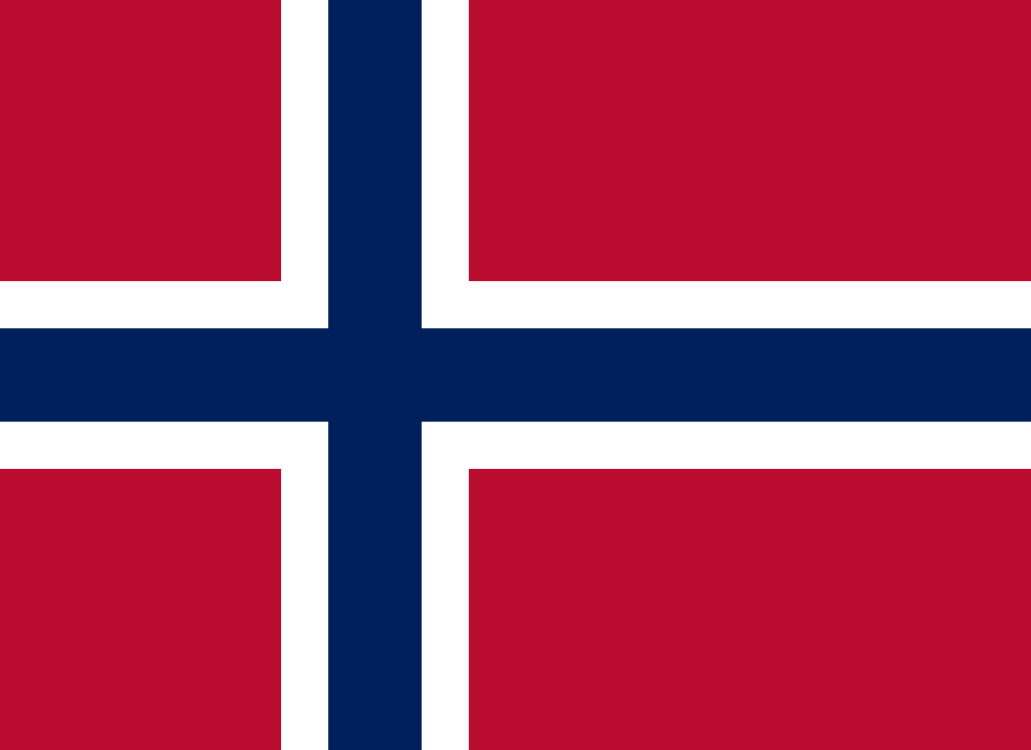
Delegation from: Norway
Committee: The Commission on the Status of Women (CSW)

Recognition and Visibilty of Transgender Women
The degree of recognition provided to transgender people varies widely throughout the world. While the number of transgender people are increasing rapidly in the last years, transgender equality is becoming more of an issue. In year 2020, 350 transgender people were executed brutally. Not only transgender people, but the whole LGBTQ community is getting their rights disregarded in many countries.
Norway is a staunch defender of the human rights with no exception for transgender people. On 18 March 2016, the Solberg Government introduced a bill to allow legal gender changes without any form of psychiatric or psychological evaluation, diagnosis or any kind of medical intervention. We believe that having a gender identity or gender expression that differs from the sex that you were assigned at birth, should not be acknowledged as an illness. Therefore Norway has a law prohibiting discrimination based on gender identity since 2013. Moreover, as of December 2019 the Storting is considering a ban on conversion therapy. The Norwegian Psychiatric Association, overwhelmingly stated that a ‘treatment’ with the only aim of changing gender identity must be regarded as ethical malpractice and should have no place in the health system. The research on such treatment has disproven their efficacy, and also has indicated that they are affirmatively harmful. Every single person should be given the right to be who they are regardless of their gender expression. As one of the world’s most LGBTQ-friendly nations, Norway is deeply concerned about all the hatecrimes that are being committed against the transgender community and has devoted attention to stop all the possible transphobic acts.
As a result of being a gender equal country, Norway has a high societal acceptance of transgender woman. All women are equal without any needs of surgery and irrespective of their biological sex.
Minority groups such as transgender women commonly lack equal rights. We believe it is important to cooperate with other countries and organisations to ensure that everyone’s human rights are respected including the transgender community. To govern with such an issue, national human rights organisations should be urged to include ‘transgender equality’ as a theme in their work. Countries should take action to decrease the hatecrimes against transgender people to insure their safety.

