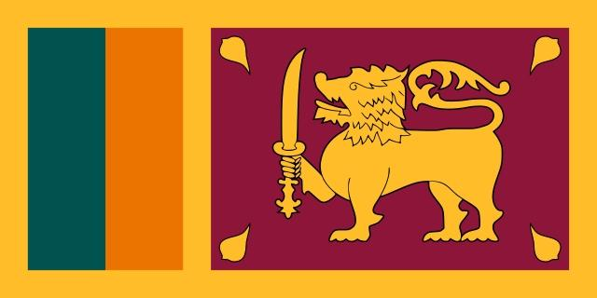
Committee : UNODC: United Nations Office on Drugs and Crime (UNODC)
Topic : Money Laundering and Countering the Financing of Terrorism
Delegation : Sri Lanka
Delegate : Efe Aras Özçelik

As we all know one of the biggest problems of today is money laundering and financing terrorism. Money laundering is the transactions and actions that show the assets obtained from crime as income obtained from a legitimate source in order to hide the illegal source.

There are different types of money laundering such as tax evasion, theft, fraud, bribery and terror financing. One of the most important among them is financing of terrorism. Terrorism financing raises money to support terrorist activities.

The Basel AML index mesaures the world’s annual progress against money laundering and terrorist financing across 144 countries. In 2020, the report showed that the index is 5.22 out of 10, where 10 is the maximum risk. Of 141 countries assessed by the Basel AML Index, Afghanistan leads the world as the country with highest AML risk at 8.16, where 10 is the maximum risk. According to the United Nations Office on Drugs and Crime (UNODC), the assessed measure of laundered cash in one year is around $800 billion, which is 5% of worldwide GDP. According to the report, only six countries had shown improvement in anti-money laundering. Also ​The FATF welcomed our significant progress in improving its AML/CFT regime and noted that we have strengthened the effectiveness of its AML/CFT regime and addressed related technical deficiencies to meet the commitments in its action plan regarding the strategic deficiencies that the FATF identified in November 2017. We therefore no longer subject to the FATF’s monitoring process under its ongoing global AML/CFT compliance process. We will continue to work with APG to improve further its AML/CFT regime. To solve all of these, we should look for solutions together, do our best and increase the number of these countries which had shown improvement in anti-money laundering.

Our solution proposal is to inform people with various projects, to allocate a budget as much as possible to prevent money laundering, and to work together in unity. We hope that by doing these we will solve this problem radically.

