Committee: World Health Organization (WHO)
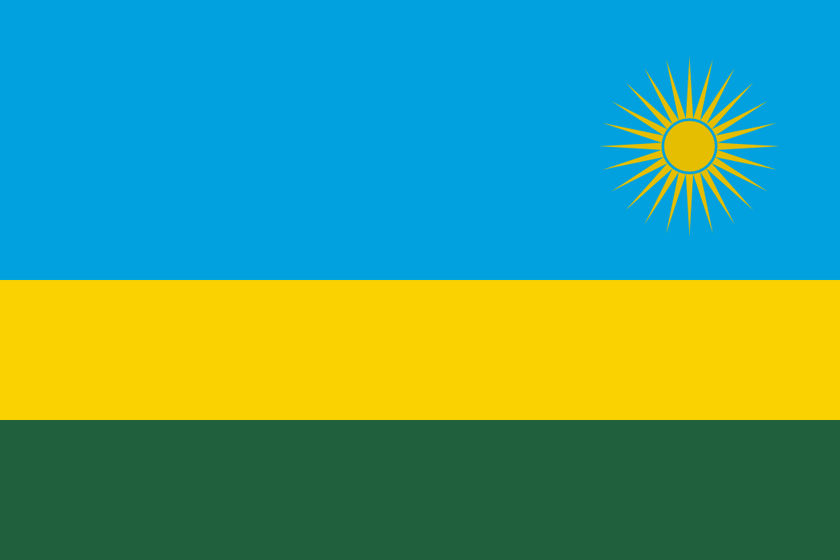
Country: Rwanda
Agenda item(s): Preventing the second COVID-19 wave in the African Region

The COVID-19 pandemic has recently become a situation that affects the whole world. So many countries have been affected badly in several ways such as economic, social etc. This is why it is so significant for the world countries to come together and create solutions in order to solve these problems.
COVID-19 is a recently discovered member of the coronavirus family. It is an infectious disease. COVID-19 is transmitted through droplets when an infected person coughs, sneezes or exhales. People might get infected if they inhale the virus while they are near to someone who was infected with COVID-19 or if they touch their eyes, mouth and nose after touching an infected surface. The virus shows itself with symptoms 5-6 days after the person gets infected. This period of time might as well extend to 14 days. The most common symptoms are fire, dry cough and exhaustion.
Recently, there are 44,6 million cases, 30,1 million healed people and 1,18 million deaths. COVID-19 has recently reached 213 countries and terrorities.
In Africa, governments took action against COVID-19 quickly. People were aware of the threat and they behaved carefully, following the rules. Especially younger and older age groups stayed at home. The climate also affected how effective the virus was going to be. Health workers in African countries acted quite responsibly.
The first case in Rwanda was encountered in mid-march. Since then, out of the 12 million population, about 5000 cases were determined and about 30 people died of COVID-19.
Rwanda is managing the process quite consciously. The number of daily cases is pretty low. Getting tested for COVID-19 is really easy. You can even get tested while randomly walking down the street. People are frequently asked if they want to get tested for COVID-19 and it takes about five minutes to get the nasopharyngeal swap test and fill in the forms according to their contact information. All the samples are sent to the laboratory the exact day they were taken. Rwanda uses a process called “pool testing” in order to see if the samples are positive. In this process, 20-25 samples are put into the same bottle and they get tested for positivity together. If one of the bottles is tested positive, every single sample in that bottle gets tested separately to identify the positive sample and determine whose sample it is. The owner of the positive sample is immediately quarantined in a dedicated COVID-19 clinic and the contacts of the case who are deemed at high risk are also quarantined, either in a clinic or at home until they can be tested.
To prevent a second wave, every member of WHO should make sure that the citizens of their country are following the simple COVID-19 rules: not getting into crowded places, wearing masks, social distancing, washing and disinfecting their hands regularly etc. If necessary, curfews might as well be declared. As Scott Gottlieb said: “COVID-19 may be here for a long time.” and we need to learn how to avoid it.

