Country: Peru 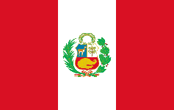

Committee: UNICEF
Agenda Item: Fighting against bad social and economic conditions caused by corona-virus
Delegate: Duru Kurtuluş

Peru is one of the countries in the east side of North America. Peru has a population over 32 millions of people according to the year of 2020 datas. Peru is one of the countries that most effected by corona-virus. Peru has one of the highest Covid-19 mortality rate in the world, with 1,561,723 confirmed cases and 52,161 deaths of which 93,076 children. Because of the high cases and deaths, The Government of Peru elucidated that the country is passing by to “national quarantine” which aim is to protect the social distances.

Peru has the second largest population of Venezualam migrants hosting over 1 millions of people which more than 190,000 are children and adolescents. By 2020, 1.2 millions of children were pushed to poverty. By the Covid-19 initiation; social, physical and economical vulnerations occured between the Venezualan families and created inclination to violence. Generally in informal labour marketing, the migrant families don’t access the national health system services and social protection benefits which paved the way for working and risk for contagious.

The Government of Peru knucle down on the immediate socioeconomic response is not helping to addressing structural amendments of the social protection system. Which enhances the risks that faced by the people who were living in poverty and the self-employed workers.

