Delegate : Asya Kandemir

Committee: UNDP

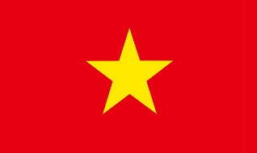Agenda Item: Production of Sustainable Biomass Energy

Honorable chairs and esteemed delegetes,we as the delegation of Vietnam is a country located in Souhteast Asia and its border neighbors are China, Thailand and Cambodia. Vietnam is a developing country.

As we all know , the limited energy resources in our World are depleting day by day. As Vietnam, we find it right to use sustainable biomass energy. So we emphasized renbewable energy in Master Plan 8 and stated that we would phase out coal by 2050. Additionally, our plan will enable the development of local biomass waste to energy projects.

İn our opinion, all countries, including us should reduce resorces that harm nature such as coal and use renewable energy sources such as wind, sun and biomass. Thank you for listening to us.