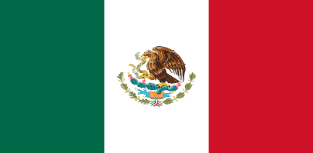Delegate: Ceylin Eylül Gümüş

Committee: SPECPOL

Agenda Item: Israel-Palestenian Conflict: The Military Occupation of the Gaza Strip and Its Implications

Honorable Chairs an Dear Delegates,

Mexico is an country located in North America , Mexico’s neighbors are Guatemala,Belize and the Caribbean Sea.Also,Mexico is a developing country.

First of all,we are not in favor of war. We find Palestine right in this ongoing war.Of course we are in favor of peace.Many innocent people and children died in Palestine,hospitals are bombed and the survivors can do nothing.And the Israelis say “ We told them to leave their country “we do not find this situation fair,we will never find it fair.

When we look at the World unfortunately we can see all the big countrys support Israel.For example USA,Italy,England… We would like to say that, we are very angry to these countries.We are honored to be on the right side.We wish all the countries will agree with us.