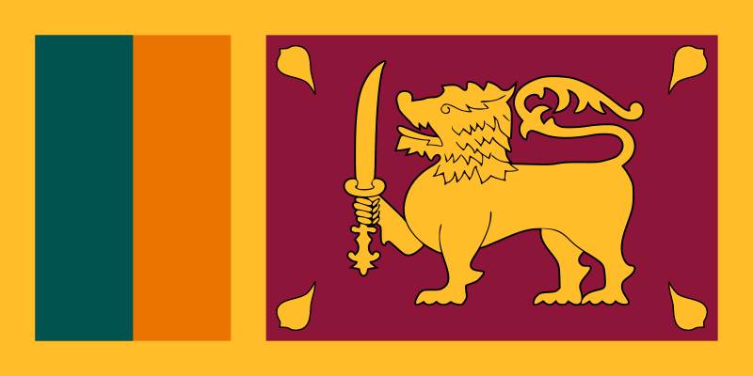
Committee: Status of Women
Topic: Recognition and Visibility of Transgender Women
Delegation: Sri Lanka
Delegate: Eren Bozkurt
Sri Lanka is an island country in South Asia right under India on the map. We have a long and rich history. Sri Lanka is known to be a Buddhist country since 29 BCE.
With human remains found on our island from 125 thousand years ago, so it is safe to say we are an old country. Our geographic location had a great strategic importance in the past, therefore the island was ruled by multiple kingdoms for centuries. Over the years the island became Portuguese, Dutch and British possession. In 1948, a movement for independence arose, and the island became the Dominion of Ceylon. And in 1972 the republic named Sri Lanka won dominion.
Being a transgender goes against our religion and we think it is an act against the order of nature. LGBT members in our country can be put behind bars for up to 10 years. The majority of our people, including the police discriminate transgender people. We haven’t recognized transgender people yet.
But our new president Gotabaya Rajapaksa is trying his best to bring equality for everyone and especially LGBT members. He is trying to change our peoples opinion on them and wants to get rid of the discrimination and legal challenges they face.

