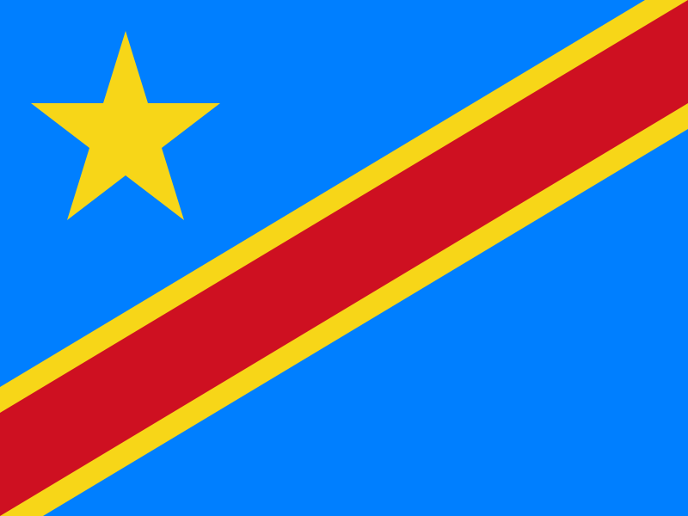
Committee:UNODC
Topic:Money Laundering and Countering the Financing of Terrorism
Delegation:Democratic Republic of Congo
Delegate:Ekin Demir

Money laundering((ML) is an increasing problem of our world..Money laundering is a process that criminals use in an attempt to hide the illegal source of income. The illegal income can be drug, human or gun trafficking and many other stern crimes. There’s a straggering amount of money laundered in countries around the world. In only a year the estimated amount of money laundered globally is 2-5% of global GDP. Crimes and illegal financing sources can be the source for countering the financing of terrorism(FT). Countering the financing of terrorism is focused on restricting the movement of funds to terrorist organizations.Terrorist organizations need financial resource to sustain themselves and carry out their terrorist actions.
Democratic Republic of Congo has a specific view on these topics. Money laundering and the financing of terror has been the issue of our country since the founding of it.It took some time for our government to acknowledge this problem,after acknowledging it we adapted Law No.04/016 of 19 July 2004 to provide a framework to combat and financing of terrorism.we have also taken institutional initiatives to strenghten our fight,including the creation of the National Financial Intelligence(GENAREF),The Consultative Committe to Combat Money Laundering and the Financing of Terrorism(COLUP),the National Coordination Committee to Combat International Terrorism (CNCLT),the Fund for the Fight Against Organised Crime(FOLUCCO) and The Observatory for Monitoring Corruption and Professional Ethics(OSCEP).These organizations helped us get better and safer but there are still some risks we face such as;
- Strong informal sector,
- The extensive use of cash due to the low level of financial inclusion,
- The high dollarization of the economy due to weak operational exchange control,
- The lack of a reliable identification system and widespread corruption,,
- Creation of an environment conclusive to crime and money laundering activities,
- Democratic Republic of Congo is also exposed to the threats of terrorism and its financing due to the presence of armed groups and gangs that can exploit various illicit trafficking and its immediate geographical and security environment.
These kind of factors are making our people feel unsafe and making our country a dangerous place to live but there are always solutions .
We can start by ;
- Adopting a comprehensive ML/FT risk assessment in the DRC to improve the understanding of ML/FT threats,vulnerabilities and risks in the country.
- Establish coordinated and coherent policies and establish sectoral action plans.
- Improve colloboration at the political level.
- Develop and conduct awareness and training programs for those subjects to Anti-Money Laundering(AML)/Combating the financing of terrorism(CFT) regulations to increase their understanding of risks.
- Strenghten the capacity of BCC.(Central Bank of Congo)
- Strenghten te operational analysis capacity of CENAREF.
- Strenghten the capacity of the judicial and prosecuting authorities.
- Developing and modernizing identity documents in the DRC.
- Taking measures to require the represantative offices of international money transfering companies.

