Committee: United Nations Women – UNWOMEN
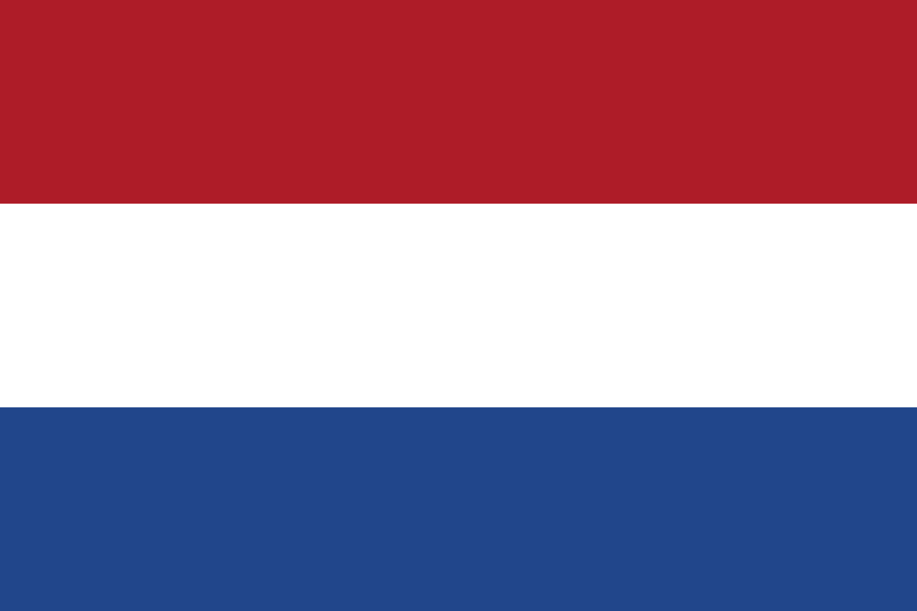
Country’s Name: The Netherlands
Agenda Item: Elimination of the Raising Domestic Violence
During Covid-19 Pandemic

The Netherlands, also known as Holland, is a country located in Northwestern Europe and shares borders with Belgium and Germany. The central part of the Netherlands’ government’s human rights policy is the equal rights for women and girls.The core issues which the Netherlands focuses on are: implementing UN Resolution 1325 on women, peace and security; combating violence against women; preventing child marriage; promoting political and economic participation by women; achieving gender equality between men and women.
Domestic violence -also called as family violence or domestic abuse- is violence or other abuse that occurs in a domestic setting. Domestic violence is often used as a synonym for intimate partner violence that is committed by one of the people in an intimate relationship against the other person, and can take place in either heterosexual or same-sex relationships or between former spouses or partners. In its broadest sense, domestic violence also involves violence against children, parents, or the elderly. It can assume multiple forms, including physical, verbal, emotional, economic, religious, reproductive, or sexual abuse, which can range from subtle, coercive forms to marital rape and other violent physical abuse, such as choking, beating, female genital mutilation, and acid throwing that may result in disfigurement or even death.
Domestic violence is also a very serious issue in the Netherlands. With the Covid-19 pandemic, the rates of the domestic violence victims have increased a lot making this issue a crisis. The Dutch government tries to prevent this problem and eliminate the rate but is in need of solution ideas which can be helpful.

