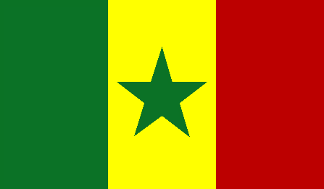
Committee: WHO
Topic: Covid-19
Country: Republic of Senegal

Republic of Senegal is a country in West Africa. Senegal’s population is 15 million. Our country’s capital is Dakar. Senegal’s official language is French, however there are different languages spoken in Senegal. Main religion of Senegal is Islam.
Covid-19 pandemic is an important issue. Our country managed this crisis pretty well until now. Even though our country’s health system was not enough, we are dealing with this issue well. There are 7 doctors per 10,000 people. ‘’We worried that we lacked equipment, for the treatment of coronavirus there were just 12 beds with limited oxygen supplies fort he whole country.‘’ says Dr Khardiata Diallo, who co-ordinates the epidemic treatment centre at Fann Hospital in the capital, Dakar. Currently Senagal has 15,582 confirmed corona cases and 322 confirmed deaths. When we look at the numbers, confirmed cases and deaths are lower than thought as we think about Senegal’s health equipments.
To lower the cases and deaths, Senegal delegation thinks that best way to solve this problem is; education. There shoud be some groups that formed by the government. The purpose of these groups will be educating people. The best and efficient way to lower the cases is this, we believe. Education about corona and how to prevent it, will make people realize that they need to be careful and try their best to not to catch the virüs. You can’t be afraid of something you are not aware of it’s effects. So we think if we educate people about effects of covid, how to prevent it and what to do if they catch it.

