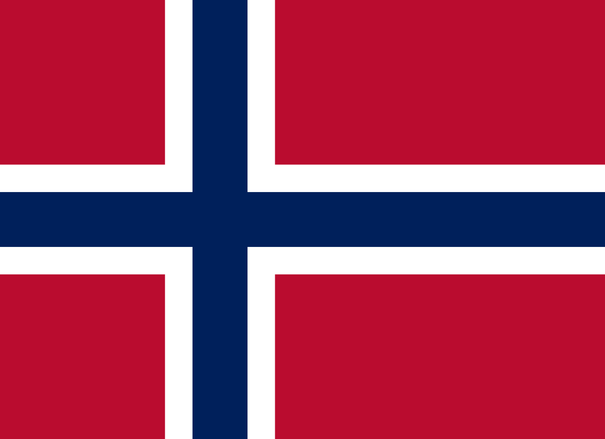
Country: Norway
Committee: UNWOMEN
Agenda Item: Gender Related Mobbing

A longstanding champion of gender equality, the Government of Norway has been a key supporter of UN Women since its establishment in 2011. The main goal of Norway’s efforts in the field of women’s rights and gender equality is to expand opportunities for women and girls, promote their right to self determination, and empower them without sexism. According to the 2020 Global Gender Gap Index Rating Report, Norway took second place in the gender parity chart. The country is one of the most gender-equal countries in the world in terms of “economic participation and opportunity, educational attainment, health and survival and political empowerment.” Also, a new study from SmartSurvey reveals that Norway is the best country in the world to be a woman in work. Compared with many other countries, Norway has come a long way when it comes to gender equality in working life. Norway has a high degree of gender equality and ranks second out of 149 countries in the World Economic Forum’s Global Gender Gap Report.
Norway is the number one country with one of the smallest wage gaps of the countries that the researchers analysed, as well as providing one of the best environments for women looking to start a business. Norway, is one of the best country for women even from harassment to work rights. The government attaches important for the issue of gender related bullying and mobbing.
In 2018, the country adopted the Equality and Anti-Discrimination Act to improve the rights of workers, minorities and women in Norway. According to the Equality and Anti-Discrimination Act Harassment based on gender, pregnancy, parental leave, caretaking responsibilities, ethnicity, religion, life stance, disability, sexual orientation, gender identity, gender expression and age, or combinations of these, are banned in country. This way the Government has taken a stand for the gender related mobbing.
As the government of Norway we can surely say that we are trying our best to reduce the amount of the aggrieved people from mobbing, bullying, harassment etc. Norway is ready for a serious discussion on gender related mobbing. We will let our women to protect their rights as the joiner or speaker of the parliament. We won’ t let our people to affect because of their own gender.

