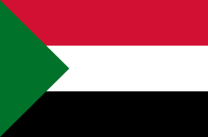
Committe : UNHCR (United Nations High Commissioner of Refugees)
Country : Sudan
Topic : Refugee Children
Delegate : Begüm Ecem Çakır , APFL

In our country, there are three million refugees and unfortunately, most of them are children. Because of various causes, they had to move to another country. Some of them are deprived of their educational rights, some of them are fighting with hungry, some of them lost their family… To summarize, they have to deal with various difficulties while they should be in school.

Yes, we admit them to our country but we can’t provide for every child’s needs because we already have financial problems so we trying the give financial aid to our people. We expect other countries to show the same attention to children and provide assistance, primarily financially. They are our children, no matter their nation, and it is our duty to meet their needs.

There are many problems in their physical development as there is a problem in the food supply. Unfortunately, there are children who lose some parts of their body, even their lives, because they cannot access the necessary health services.

Our suggestion is that each country pays some money. Each country can pay a certain amount of money according to its budget so that a fund is created and these children and their families are able to sustain their lives. Or, each country protects children as much as they can meet all their needs according to their own economy and meets their needs.

