POSITION PAPER
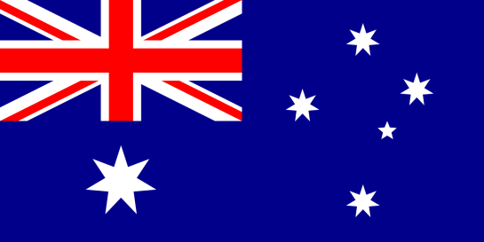
Country: Australia
Committee: DISEC
Topic: Afghanistan Issue

The Commonwealth of Australia, is a sovereign country comprising the mainland of the Australian continent, the island of Tasmania, and numerous smaller islands. There aren’t any official languages at the federal level but English is the most spoken one. Canberra is the capital city of the country, while the largest city is Sydney. Australia's population is nearly 26 million and area of the country is 7,617,930 square kilometers. The currency is Australian dollar (AUD).

The Afghanistan issue has been an enormous problem for a long time. Since late 80s there were various wars and conflicts. Unfortunately several military groups has been make this in Afghanistan. AS Australia, we solemnly admit that democracy is the nation’s voice. And if anything that happens to it, that will destroy the peace. Without peace the country won’t last for long and eventually will fall. Therefore as Australian government we are emphasizing to give a hand to Afghanistan.

We had made a lot of assistance on behalf this issue. The budget of an actual total of 1.5 billion USD on development of Afghanistan has spent since 2001. This budget was spent on health security, stability and economic recovery of Afghanistan due to our development cooperation. Also Australia was supporting NATO-led Resolute Support Mission (RSM) which is a mission that helps to provide the folk by building the capacity of Afghan National Defense and Security Forces (ANDSF). But after the Taliban has came to the control, withdrawal of the Australian forces from the Afghanistan had immediately done.

Also the unequal conditions that women get in Afghanistan express our deep concern. Furthermore the uncontrolled militarization and children’s safety is also in a dangerous position. All of these situations are because of the Taliban regime which uses religion for unfair and aggressive purposes. And all of this conditions are a further reason for Afghans to escape from their own homelands.

At this point we need to mention that during the Taliban regime Australia always welcomed Afghans who are trying to find peace. Australia evacuated 4,100 people on 32 flights from Kabul between 18 and 26 August 2021. Our government announced on 18 August 2021 that we will allocate an initial 3,000 humanitarian places to Afghan nationals. This is within Australia’s annual program, currently providing 13,750 places and it’s expecting to increase in the course 2021-22. Settlement support packages that includes a total budget of 27.1 billion USD has also announced for Afghans.

All the situations that happening in Afghanistan can be solved by some decisions. As Australia, we fully believe that we can solve these issues and make a better environment in Afghanistan.

REFERENCES
- https://en.wikipedia.org/wiki/Australia
- https://www.dfat.gov.au/geo/afghanistan/development-assistance/development-assistance-in-afghanistan
- https://www.dfat.gov.au/geo/afghanistan/development-assistance/health-security-in-afghanistan
- https://www.dfat.gov.au/geo/afghanistan/afghanistan-country-brief
- https://www.homeaffairs.gov.au/help-and-support/afghanistan-update
- https://www.aph.gov.au/About_Parliament/Parliamentary_Departments/Parliamentary_Library/pubs/rp/rp2122/Quick_Guides/BackgroundToAfghanistanWithdrawal
- https://www.foreignminister.gov.au/minister/marise-payne/media-release/mikta-statement-situation-afghanistan
- https://www.dfat.gov.au/crisis-hub/afghanistan-crisis-and-response

