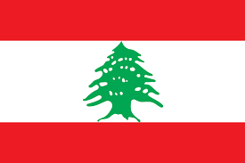
Country: Lebanon
Committee: the Commission on the Status of Women (CSW)
Agenda Item: Recognition and Visibility of Transgender Women
Delegation: Mehmet Yağız ACAR
Lebanon is a republic which is located in the Middle East. Lebanon covers an area around
10,400 square kilometers. Lebanon has a population of approximately 6 million people and
population steel increases.
In 1885, the first law that prohibits transsexuality was adopted by the United Kingdom.
Similar laws were introduced throughout Europe. Since 1917 various surgeries and
treatments were performed. Since 1972 it’s possible to legally change your gender markers
with some conditions (being Swedish, being older than 18 etc.) in Sweden. Then step by
step most nations followed up Sweden.
Lebanon’s Penal Code 1943, Article 534 mentions that “Any sexual intercourse against
nature is punished with up to one year of imprisonment.”. Lebanon refuse to recognize
transsexuals and crimininalize them. Not only the government but also almost 80 percent of
people think that “homosexuality should be rejected by society”. As people and nature
demands transsexuality is unrecognized in Lebanon. But Lebanon doesn’t think that it is a
disease that needs treatment. So these kinds of actions are punished with imprisonment.
We think, to create a society which is stable and obeys laws as wanted we need to punish
these kinds of tendencies / actions. If all countries come to agreement on this topic,
regardless the sacrifices that all sides make, we can achieve a better society.

