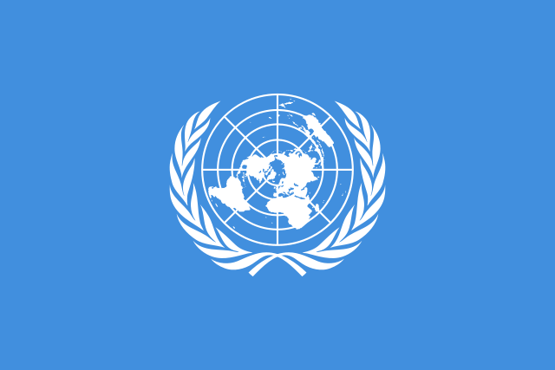

Assurance of Equal Pay for Services of Equal Derivative Values Between
Men and Women

Country: Italy
Committee: CSW (Commission on the Status of Women)
Delegate: Özge ÖZER

One of the biggest problems in the world is “Inequalities between Men and Women”. All around the world, most employers are afraid of employing women just because women are found insufficient for various jobs by many different cultures. Employers think that if women have a child or get pregnant their job can not be one of their priorities. Due to this fact, there are a lot of unemployed women who lack the benefits and money of work. As the delegation of Italy, we believe and trust in the power of women in their role in sustainable development and policy. Just as it’s supposed to be all around the world. We are open to cooperation in any solution proposals to be made to eliminate inequalities in the economic sector for women.
In Italy, female standards at work are generally of high quality and professional, but are not as good as in education. The probability of a woman getting employed is mainly related to her qualifications, and 80% of women who graduate from university go on to seek jobs. Women in Italy face a number of challenges. Although gender roles are not as strict as they have been in the past, sexual and domestic abuse is still quite prevalent in Italy. On average, women do 3.7 hours more housework than men. Men make up the majority of the parliament but more than a third of the seats are held by women (around 36%, a higher rate than countries like Netherlands and Germany, as well as the average EU rate), which makes Italy the eighth country the EU by the percentage of women in the national parliament.
Additionally, women in Italy are not adequately represented in the workforce, as Italy has one of the lowest rates of employment for women of the countries within the European Union. Women's employment rate (for ages 15–64) is 47.8% (in 2015), compared to 66.5% for men. Which we have to take action on it and make women become more accitvetive in policy and economic sector.
Today, there is a growing acceptance of gender equality, and people (especially in the North) tend to be far more liberal towards women getting jobs, going to university, and doing stereotypically male things. However, in some parts of society, women are still stereotyped as being simply housewives and mothers, also reflected in the fact of a higher-than-EU average female unemployment.
In Italy, around 36 percent of Parliament representatives are women. As regards the female representation in ministerial positions, about three in 10 people are women. Among the G20 countries, no parliament or minister has a female majority. in Ministerial positions, only Canada and France have an equal balance of women and men. This shows that women’s position in policy in Italy has been improving as the years passed away.

