Committee: UNICEF 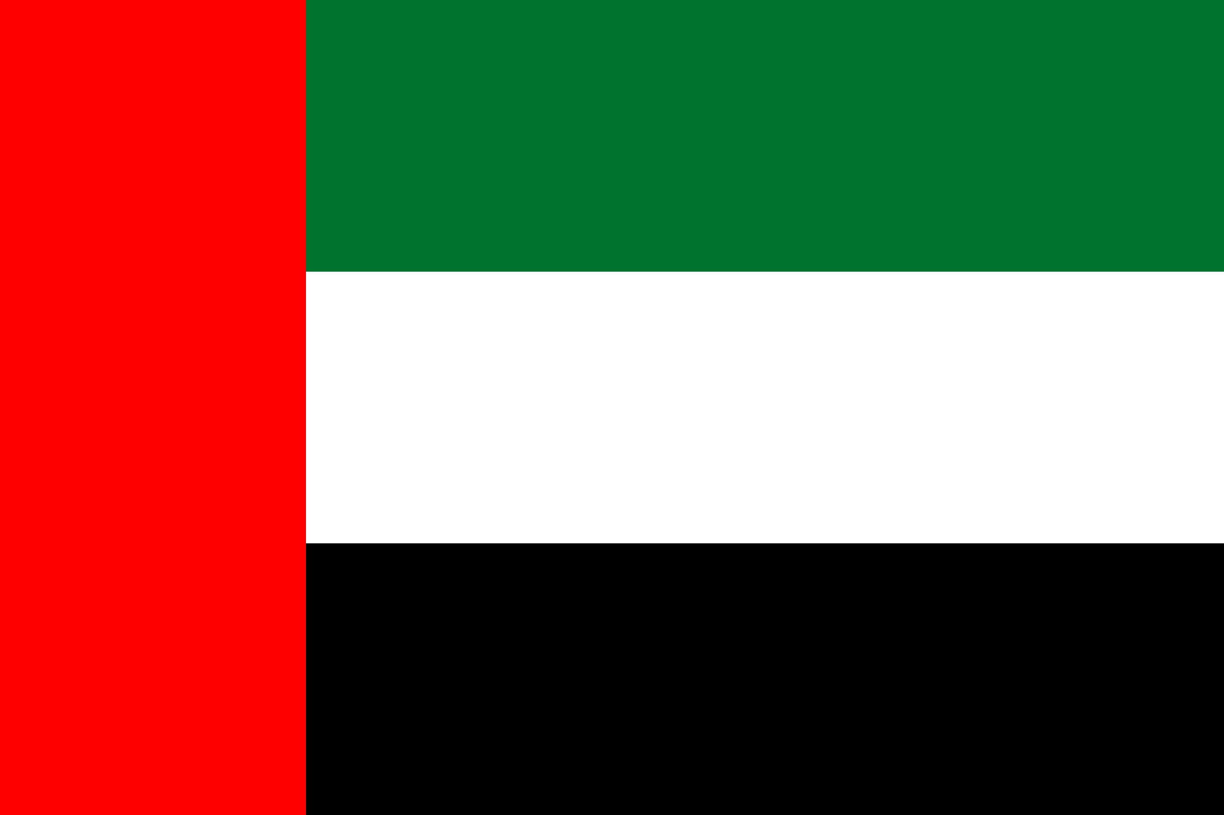

Country: United Arab Emirates
Agenda Items: Fighting against social exclusion and child poverty, Providing education during emergencies
The United Arab Emirates is the third richest country in the entire world, with a GDP per capita of 38,661 US dollars. It has a great diversity of people and cultures with the top 5 languages being English, Arabic, Urdu, Malayalam, and Hindi. As an important strategic location in the Arab Peninsula, the UAE initially attracted many merchants from India and China. It was mostly in British contol throughout its history when it finally gained independence in 1971. Its economy is an advanced and open economy that grows every day and doesn’t rely on other countries to sustain itself. The UAE is also known for its huge amount of financial help to Egypt and actively taking part in anti-terrorism. The UAE joined the UN 7 days after its initial gain of independence and still plays an active role in it as well.

More than 72 million children of primary school age are not in school, and the number of children in poverty is much higher. It is definitely a serious issue which affects a lot of countries and our future since children are our future. For reasons such as natural disasters, famine, war, and poor financial conditions many children don’t have access to school. This low level of education and poverty also affects the next generation. Since people are not educated, the country continues living in poverty. And because of poverty, education rates become low. To break this loop, the UN and the UAE have been working on this issue for a long time. For example, the UAE donated 8.9 billion AEDs to stop child poverty worldwide. UNICEF plays a key role in stopping child poverty as well. They donate uniforms, school materials, and food to schools. They have advanced systems to monitor child poverty to better counter it. They also have programs like FreeRice, which motivate people to learn more.

The UAE has strict policies when it comes to child poverty and education as one of the top donor states of the Official Developmental Aid. Starting school at a young age is compulsory, and the Ministry Of Education currently has 10 billion AEDs set apart solely for universities and education. As mentioned above, the UAE also donated 8.9 billion AEDs to stop child poverty globally. Also, in 2016, The Ministry of Foreign Affairs launched the UAE Foreign Assistance Policy which plans on eradicating poverty worldwide and promoting global peace. As education is crucial in a human being’s life(being the stepping stones of their life) it should be treated as a basic need like water and food. So the school materials should be provided by the school. For situations like war; where the school building isn’t safe anymore, countries can build tents just like medics do in wars. Instead of a big hospital, there is just a medical tent that can meet the basic needs of soldiers on the battlefield which is not costly and mobile. We can implement this for education as well. When a school is not safe, people can build tents temporarily to continue education as usual. With the economical level of the UAE and its actively taking part in aid programs, it is apparent that the UAE as a country is working at its full capacity to stop child poverty and lack of education.

